Entrepreneurship Report
Written for BUREAU, EST. 2021
By: M. Çağatay Sipahioğlu

Table of Contents
1. Mental Rewiring Mehmet Bey, Naval 5
Why Quit the 9-5 mindset? 5
Utilizing the 9-5 Part of Your Life 5
Do you want to be rich or is it really wealthy that you want to be? 6
What to Sell for Wealth? Build a company. 6
What to build to create wealth? 7
After obtaining leverage: Get Perspective 12
Your Assets 12
How to sell? 13
Misc Principles 13
Hayatta kalma rehberi M 14
Jews 15
Başarının Ölçütü M 15
Yalın Girişimci kimdir? M 15
Summary via Millionaire Fastlane 16
2. Who is an Entrepreneur? 19
Principles of Entrepreneurship M FUI 20
Who is a good leader? M 24
To Cofounder or not to Cofounder 25
The Lone Founder Teknofestteki girişimci 25
What is a good team? M 26
3. How to Find and Solve a Problem? 27
Footnote on Finding a GREAT Problem 27
How to Isolate a Problem (Design Thinking) FUI 28
Anla 29
Gözlem = Mülakat (Find all the things that are not seen) 29
Tanımla (Sieve the problems that matter) 30
How to Isolate an Initial Solution (Design Thinking) FUI BAZI YERLERDE ÜRÜN DEDİK BU CHAPTER BOYUNCA ÇÖZÜM DENMLEİ (Editte hallet) 33
Fikir Üret 33
Prototiple 33
Test Et 34
Business Plan (Result of the Design Thinking) 35
4. What is a startup? M FUI 39
Funding- When and where? The Funding Ecosystem 39
The Pitch Deck 39
How to sell? 40
How to scale? 40
5. R&D 40
6. Marketing 41
3 Lines Theory (What is the aim of marketing?) 41
Branding 41
Brand Naming 41
Creating a Brand Following 42
7. So You are Rich, What Now? Invest. 42
Doing it backwards: Rise of the Digital Creator 43
BFFs with the Government: The Contractor Way 44

- Building your idea
- Marketing
  - Marketing channels
  - Feedback channels
  - Analytics
- Scaling Up (or not)
- Exit (or not)
- Investing
Pitching to the Investors (can be done earliest after 2.g i.e. Seed investment,)
- Why get an investment? (To work on it full time or necessary capital)
- Why should someone invest in you anyway? (A peak behind the curtain)
- Business Plan
- Analytics & Terminology

Mental Rewiring Mehmet Bey, Naval

Why Quit the 9-5 mindset?
- To be wealthy. 9-5 will never give you enough money to be rich or enough time to spend it.
- In 9-5 Your inputs are matched to your outputs, you are replaceable and you are not being creative. (Even in doctors or engineering, you are doing things over and over. Eventually you will be replaced by AI or robots)
- If you are not leveraging time you will never be wealthy. Wealth is about positive sum games. Finite games like selling your time can never fulfill you since you will try to consume luxury and your free time to feel better about your life. But the truth is the only endevour that can really feed your soul is creating something.
- Leveraging
  - Employee-no leverage. Money=Time (You get paid 1% of the value you create)
  - Self employed-no leverage. More money=Time (You get paid 100% of the value you create)
  - Businessman-leverage. Money=Time^2 (You get paid 1% of the value hundreds create)
  - Investor-leverage Money=Money^2 (You get 1% of the value millions create)
- When you are 80 and looking back on your life, you probably won’t regret having become an entrepreneur or at least having tried with everything you got and even failed. The one thing you will regret is though is having never tried.
- En güzel yere de girsen, kendi fikrindeki şeyleri yapmazsan hayat monotonlaşçak.
- Entraya ne zaman başlanır? Whenever you have the guts and the idea (You dont need to quit to start becoming an entra)
- There are people less qualifeied than you, doing the things you want to do, because they believe in themselves and take action. (Jack Ma)
- You are getting soft again, gotta earn money, gotta get ambitious
- Income Types
  - Earned income (From a job)
  - Profit income (From trading)
  - Interest income (From lending money)
  - Royalty income (From lending your idea)
  - Dividend income (From owning stocks)
  - Rental income (From owning property)
  - Capital gains (From your assets increasing in value)
  - Residual income (When you continue to get paid after your work is done. Online courses etc.)
- A loser is someone who is so afraid of trying they dont even try
- If you can be trained to do a job then so will others and you are replaceable.
- Become your own boss as fast as possible, It is the only way to make your life truly yours

Utilizing the 9-5 Part of Your Life
- Use your 20s to learn how to make money, start a business, invest in yourself, get valuable skills.
- Daha çok para istiyorsan şirket değiştireceksin. Seni promote etmesi demek alttan bir sürü adamı da promote etmesi demek, o zaman hepinizin baştan eğitilmesi gerekiyor. Onun yerine senin üstündeki kadroya dışarıdan birini alması çok daha efficient.
- Insanlara bakmayi ihmal etme. Beni gun icinde drive eden sey yaninda calistigim insanlar, hayatta da işte de çevrendekilerin kalibresinin yüksek olmasından daha önemli bir şey yok.
- Outlier = someone with incredible edge over others for something. Your edge is what defines you, Dont let it go dull. Senin ME icinde robotik olman edgein, bu edgeini kaybetme, Ms Phd devam et o edgein derinlesmeli hayat boyu tutmasi icin. Simdi business tarafina girden birkac sene sonra daha generalist bir kisi olarak cikican o edgeini kaybedicen. Outliers show the pattern of choosing the right opportunities that will differentiate them 10 years later
- Senin belki de profluga kadar gormeyecegini ongoruyorum, sana cok monoton gelme ihtimali var, Ama en azindan bir phd edgeinin derinlesmesi icin onemli. Business tecrubesi kazan evet, Su an o biraz eksik olucak, Ama simdi mi bunun zamani, Sonra olmasi daha mantikli olabilir.
- Onun VC secmesinin sebebi kendini bir adet projeye immerse etmektense daha cok sey uzerinde calismayi tercih etmesi
- Business sektoru all in all bi usta cirak iliskisi. O yuzden ne kadar erken ne kadar dogru insana yapisirsan o kadar iyi. Ve doğru bir mentor bulduğunda da ona yapış! Yanlis insanin yaninda 5 sene calissan hicbir sey ogrenemeyebilirsin Bir mentorun sana katabilcegi sey invaluable Even if your current job doesn’t allow for a mentor try innovations.
- Bu sosyal hobilerini de boşa atma. Onlardan birinde derinlestiginde gelecek fullfilment da hayatini wholelastiracak bir sey olabilir (Spor etc. bunlar)
- Hobin para kazandircak hobi olcak Burada calisirken mesela girisimciligi yapican sonra da ayagini saglam basip pergel gibi acilmak.
- Baskasinin isine 13 saat ayiriyosun, kendi isine 13 saat ayirsan tas satsan bile para kazanirsin
- Either learn or earn. Either is fine, both is best, but if neither quit
- Imagine playing monopoly and never buying anything that made money, just colelcting 200$ a you pass go. This is the usual employee's life.
- If you don't find a way to make money while you sleep, you will work until you die.
- You are not born to work for others all your life, that would be modern slavery. (A simple blacksmith in the middle ages had his own business.)
- Become financiallly literate.

Do you want to be rich or is it really wealthy that you want to be?
- Money without free time is worthless, free time without money is pointless. Rich is measured in dollars, wealth is measured in time.
- Wealth is businesses that can earn you money while you sleep. Purpose of wealth is freedom. Money is how you transfer wealth.
- Focus all your abilities on obtaining asset, never let go of your assets. Assets: Business that doesn't require your attention, stocks, bonds, real estate, IOUs, royalties (art, patents etc.) focus on building your business not your profession.
- You need to create wealth from ideas, technology and art.
- You can create wealth with limited risk. We’re genetically wired to be a pessimist. But now world is safer, you can just play with an investor’s money. So you need to take some risk because you can have unlimited upside.

Being able to create wealth is a skill set not luck.
- Creating new businesses/startups has nothing to do with loving the subject of that particular business. You as a person would have the job of businessman i.e. creating new businesses. You need to love solving new problems, producing better products or creating new ideas.
- %1 of people are still 80 million people
- Think that in the whole world everybody was working normal jobs
- Except the nation of Turkey
- Imagine that the population of Turkey was overseeing the whole world s trade, production and new business creation
- For that amount of a population you would start thinking these guys are getting lucky and start thinking these guys are teaching each other something we dont know
- And that is precisely what happens
- These people have a different mindset and they improve themselves in areas that will allow them to establish businesses and start ups.
- And just as for most of you getting a job is normal and you try to get the best job you ll love
- For these people building a business and developing and selling products is normal and they try to build the best busineess they ll love
- (One of the main differentiators is a perception of solving a problem themselves and selling it as opposed to solve problems for someone else)

What to Sell for Wealth? Build a company.
- Everybody makes money at some point; owns a part of a business, a product or an IP.
- You must preemptively eliminate roads that will make you 100$ max every month, like affiliate marketing, by using the commandments. Because it can trick you into thinking this is a fastlane and I am making 100$ because I am at the start.

- Privatize and productivize yourself.
- Wealth is built through practicality not passion

- You want a career where your input doesn’t match your outputs. Software engineer can work for a month and create bitcoin, or work for a year and create software no one wants to use. It is highly disconnected. The best lumberjack in the world on the other hand has no option but to tie his input to his output.
- Society always wants new things, you gotta find what is next thing people will want that they don’t know that they want it. The path to wealth is through creating things that make others happy. Find which is within your skillset and then build it and scale it. (Entrepreneurship) Everyone has dug through all the obvious places to dig. You should either dig in a new frontier or dig deeper than everyone else.
- YOU want it, WOU need it and then you build it.
- Due to internet, you can reach EVERYONE on the world. Through mail, ads, videos etc. Now, however niche your skills or interests are, as long as you are the best at something you can now find your audience.
- And for the creator economy: Don’t imitate, don’t copy, just be who you are. No one can be you better than you are. (Ludwig)
- IF you can do things that nobody else can do you’ll have skills that are literally priceless. Acquire skillls that nobody else has escpecially in combination that are rare. For career and life. Be able to build, sell and manage.
- If you want to only make Money you wont succeed. The ones that succeed is the ones that have an idea that want to get out to the World and they need a company for people to start listening to them.

What to build to create wealth?
- You can’t be number 1 at a random thing. When searching for what to do: I want to be best at something but you must also iterate until you find something that fits you.
- Enemy of a startup is everyone else's life.
- Finder product market fit: The founder is naturally inclined to build products for that market.
- Don’t get trapped in competition. To escape competition just leave other people and build a product authentic to yourself, that no one else can do. Who can do the best you better than you?
- Authenticity naturally gets you away from competition. Don’t be authentic if there is not a market fit. You gotta adjust that somehow where there is a market and you are still your best authentic self.
- If market is too filled or too empty those might be red flags.
- Generally people will get caught up in being like the competition when they enter a new market. And the best founders tend to be SIMPLY AUTHENTIC in the market. (Reddit botta da yapılmışın aynısını yapıp napcan, farklı yap, senin istediğin gibi yap.)
- Bir şeyi yapmak istemen lazım, o şeyde specific knowledgea sahip olman lazım ve yapmak istediğin şeyin Pazarı olması lazım.
- Authenticity by stacking 5 or 6 skills you are good and authentic at. People have multiple skills, it is natural that people’s own niches will join together. Ideally end up specializing on being you.
- Silicon valley businesses endanger your business. But as similar restaurant in another town will enlarge your market. Most usually another business won’t endanger your business, you will all have a niche way of doing things and differences affecting people’s choice. In that case it just helps grow the market. (Look at webex, zoom and skype) But as always authenticity is the best way to not really be affected by competition. HOROZ
- Even if you have all the bits and pieces it will still take time. Word isn’t an efficient place.
- Don’t keep track and don’t keep count.
- In entrepreneurship you only need to be right once.
- You are better off just picking off the sginle biggest thing or two. Like what am I really good at according to observation and according to people I trust that the market values? If you are good at it you’ll keep it up, if you’re good at it you’ll develop the judgement, if you’re good at it and you like to do it eventually people will give you the resources and you won’t be afraid to take on accountability, so all the other pieces will fall into place. Product market fit is inevitable if you are doing something you love to do and the market wants it.
- Best founders listen and read about everyone but go do their own thing. You should examine everything and take the parts you find correct. Because if you listen to everything others say they will just cancel each other out.
- Just make something 1 or 2 people will LOVE and use. Then iterate on it iterate on it and iterate on it. What is it, Who's it for, What problem does it solve, Does it solve it well? Dont obsess over perfection, iterate in front of users. Dont not ship, ship and fix. (Problems in shipping) Have a clear sense of your direction
- Pick up a problem around you that you understand. You usually need to see a weirdly specific problem and you need life experience to see that which is not always found in students going for startups.
- Yeni girişimler çok niche, baya 3 layer deepte yatan problemleri çözüyor. UPGRADING SUBSTANDARD VIDEO MEETINGS INTO HIGHLY ENGAGING SESSIONS. Wtf yani. Ben zoom var ya der geçerim mesela

Who to become to create wealth?
- Trustworthy
  - Pick an industry where you can play a long game with long term people. Without compound you cant grow, without long term industry you cant compound. In order to be succesfull you need to play with people. In order to always be succesfull you need people you can trust that you can easily succeed with.
  - IN short term everybody is making themselves rich. In long term game everybody is making everybody rich.
  - Humans collobarate through genetic differences. Animals only do it in packs if they ever do it. And we can do it bcs we an keep track of debit and credit. Bcs we have capitalism and it is inherently synonymous to our nature. And you gotta play the game.
  - By increasing trust you can do much more frictionless business.
  - You want the kind of reputation, that people want to do deals through you. Your reputation and brand is part of this.
  - Become someone smart, high energy (world’s filled with smart, lazy people) and high integrity. (Otherwise they will cheat you.)
  - You want to be ethical and you will attract other ethical people in the sector.
  - You wanna be honest because it leaves you with a clear mind. You don’t have two threads running in your mind all the time one keeping track of the lies. And by being honest you reject people who only wants to hear the pretty lies. But long term you create room for people who accept you for exactly who you are.
  - You might be advantageous to be a liar in the short run, but there will be honest people who will see your games and will avoid you. And in the long run those honest people will go on to become the game makers because they will have the credibility and people will come to you.
  - Relationship has compound interest, you know you got each others back. Similarly in etrepreneurship a founder you have a track record with is very valuable to decrease friction in your new startup.

- Knowledgable
  - Most interesting things can’t be taught but they can be learnt by doing. Specific knowledge: How to manage a fleet of trucks. Specific Knowledge is at the edge of knowledge and usually learnt through genuine curiosity. It will be play to you that is job to others. Only can be built through obsession! Pick things you are a natural at and double down on that!
  - If you are good at arthmethics, programming, writing, speaking and meeting you are set for life.

- Competent
  - You can be lucky (blind luck). You can be creating a lots of opportunities and some will work. (That’s hustling luck. Fortune favors the bold) You can be good at spotting luck. (That’s entrepreneurial luck) Lastly, you can be great at what you do and luck will find you. (You can attract that luck while no one else can even attempt to attract it) You are the best deep sea diver. A sunken ship is found. Their luck just became your luck.

- Builder or a Seller? Both!
  - The magic combination: CTO + CEO. (Wozniak and Jobs) The ultimate: Both! (Elon Musk) Builders can become sellers easier than sellers can become builders. (Even if you are not good at one-to-ones you might be great at writing which you can leverage.) In the beginning builders are more advantageous because there are a thousand hustling sellers and the tech the builder builds speaks for itself. But over time competing with emerging areas and technologies is not scalable for a person as it is a job requiring too much time and focus. Instead selling scales better over time. Being known as a great seller, marketer, communicator etc. will in practice self-fulfill and your words will have a noticeable heft to ordinary people which only re-affirms that you are a great seller. It is better to start as a builder and transition into a seller.
- A Learner
  - Read what you love until you love to read. Read the things that naturally interest you.
  - In order to eliminate junk in books, read foundational books like Adam Smith Economics.
- A Doer
  - Doing is faster than watching. In order to optimize your learning curve: DO! A lot of the subtleties don’t show themselves without getting in the job. You can read about a 1000 businesses but you won’t learn as much as running a lemonade stand. Also don’t repeat what you do in your business everyday, do something different, iterate every day. That is how you learn.
  - You need to be a rational optimist. It is ok to shoot holes in things as long as you come with a solution. But other than that you MUST keep pour chin up and do do do!
- Not Motivated -> Consistent
  - People work effectively by sprinting when you are sprinting. You sprint, you reassess then you try again. Then you rest a lot. More like a lion hunting. Impatience for actions and patience for results. Whatever you are doing, do them quickly with full focus and as soon as you are inspired. Inspiration is perishable. It takes great products to emerge as you polish away.
- Not a Quitter
  - talent is not the most important part of this job
  - it s having balls
  - all these people would crumble the first time someone rejects one of their "brilliant" ideas
  - which happens all day every day
  - now are you gonna make anything good?
  - i dont know
  - but you sure as shit arent gonna quit until you do
  - all these people they would give up like almost rightaway
- Accountable
  - Take accountability for your product. Your name will mean quality or it might mean uncredibility. (Trump) But if you do it well, you will gain a lot of power.
  - By accountability, you will get more credibility and equity. (If you are more accountable you are less replaceable) (Greater upside, limited downside)
  - Carpenter has no leverage, no credibility, no specific skills. The contracter has accountability and labour advantage. The developer takes more accountability, capital, risk and specific knowledge about where the hot spots are. And the upper level is a famous architect with credibility. The upper level is mega builders which must now know about financial systems as well. One level up is also understands real estate and tech, now you know how to raise capital, what to do, how to use tech to improve and you are an entrepreneur and high risk giant reward leverage in code, capital, labour of high quality (Engineer, designer, marketers). More and more kinds of knowledge that can only be gained on the job and aren’t common knowledge, more accountability, risk taking; more great people working on it, more capital, more code and media on it. You expand the opportunity (real estate) from a day labourer to a real estate tech company and took it public.
  - In general you’ll do better in a small company than a big company. You will have more accountability, you will have more visibility. And smaller companies value merit more than politics whereas in the bigger companies it is the opposite.
- Visionary
  - Principal agent problem: If you want it done right, do it yourself. Because other people just won’t care. In microeconomics the principals want the business to make the most money, the agents want to do the things that will make the principal happiest or make themselves the most money. So foor example in a widely publicly traded company where no one owns more than 1% of the company, the CEO just fills the board with his friends and does the things that pays them the most. Because there is no principal left in that system. You have to get the incentives right. The good ones aren’t usually looking for only money but for status and meaning in what they do. As a business owner you will always look at how to give them a founder mentality. (How to get them to care) You should take your top liutenants, be very generous with them in case of ownership and incentives. Because they may not realize it now but over time they will and you want them to be aligned with you. Because if they find out they are not incentivised enough they will get misaligned with you. Undermine you or quit. Secondly if you want to be a good employee you should also have the principal mentality. Because this way first you are going to be getting experience in how to be a principal long term and a good principal would promote you even if you are very young because of how you think for us and not for you. If you can hack your way to this problem then you have half of everything solved to run a company.
  - If you are an agent best thing to do is just think what would the founder do. It is only a matter of time until you become a founder yourself.

- A calm mind, a fit body and a house full of love. Even if you have all the money in the world these are things you can’t have without working. You have to cultivate these.

How to create wealth? Obtain leverage.
- Taking risk, capital, labourer, coding, communicating.
- Obtain specific knowledge: Early on find things you have any interes. If you dive into the edge of knowledge and take on things nobody knows how to solve and you solve the hard problems people will line up behind you the leverage will come.
- There are also timeless specific knowledges: Persuasion. But requires a combination with other specific knowledges.
- What to do with leverage? You have a lot more risk and more to gain. You have gone from steering a sailboat to an ocean liner. Gotta slow down and get some judgement.
- Leverage digitizaliation
  - Oldest form of leverage is labor. (More people is better) <- Very old thinking. Now have as few people working for you as possible. Capital is the newer leverage. Money from venture capital. You can lose it and owe nothing. That is why having a specific skillset and credibility is important. Because then leverage will find you. The newest leverage is digital. Last generations fortunes were made through capital but new generation’s fortunes are made through code, digital IP. New Tech: Magic Combination: Get the smallest high effect labour (engineers), add in capital to pay them and pay for them (VC, Angel) and produce distributable, scalable products which are DIGITAL.
  - New leverage is PERMISSIONLESS You need permission for someone to work for you, you need permission to get money from investments. You don’t need any permissions to create code or media. (Even capital and labour are becoming permissionless through crowdfunding and opensourcing)
  - Tech and media has amazing scale economies.
  - Tech and media has 0 marginal cost of reproduction. They also have the network effect. Because each people added will open your platform to more people than the ones you added. It has a highly compounding effect.

- Leverage Connections
  - Network Effect: Each user added adds a value to the system. Language is the oldest example. Because enough people speaks English as a majority in the long run everybody will be speaking English or Chinese. Because there are so many more English books, movies and overall resources written in English now it pushes people to learn English.
  - If your startup has talent or customers you will end up with more money than you invest.

After obtaining leverage: Get Perspective
- You have a lot more risk and more to gain. You have gone from steering a sailboat to an ocean liner. Gotta slow down and get some judgement.
- If your judgement is demonstrated and credible (like Warren Buffet) people will literally throw money at you to manage. Because at a %10 better judgement than the next guy the compounding effect will be giant when millions are given to you to manage.
- Judgement: Knowing the long term consequences of your actions and using them.
- Best judgement is given without emotions. Emotions must not blind you.
- You are accountable for your judgement. Judgement is the exercise of wisdom. Wisdom comes from experience. Experience can be accelerated through rapid iterations.
- What you need is studying everything. Becoming a philosopher. Becoming stoic. This way you won’t manage anything on emotions.

Your Assets
- Time
  - No one is going to value you more than you are. You MUST value your time above all else. You must give yourself an hourly rate and see if taking a one hour commute is worth for the discount. Pick that number absurdly high! If it is not absurd to you, it is not high enough. Now whenever you are using your time on anything but your hustle deduct yourself at that rate. And whenever you are working on your hustle pay yourself at that rate.
  - Ruthlessly dodge meetings. You are literally dying one hour at a time. Make it a walking meeting, a phone call, an email.
  - You need free time and free mind.
- Internal People
  - Order of operations: What I should be doing (Emerging market, I have knowledge in it and I want to do it) Surround yourself with the best people (Choose the best alumni network etc. Look at the Paypal mafia they all got absurdly rich) Then you work as hard as you can.
- External People

  - Deal with the smallest firms possible. Bigger firms are usually worse, the principal and the agent are highly separated. So the principal will sell you the service but the agent will probably not care as much.
  - By working with booutiques yes you are betting big on one person or one small group but there are no other throats to choke, the accountability is very high.

Quitting your 9-5: Leap of Faith
- Ludwig got 10k in savings, quit his job and also set a goal of subscribers etc. Then he went all in for 8 months and he says himself that he would have definitely quit if he didnt reach the goals. Taking a few months full time to throw yourself at something you are passionate about seems worth it. The upside is your life will be saved. Downside is you will maybe see what you are not made of but even then you may find a new passion and in either case you will come out with a lot more knowledge than you went in with. You can do stuff half assed as a side job but the results will be half assed to. For youtube for example if you are able to produce barely 1 video a week vs. 3 videos a week + all day everyday learn about growth and the algorithm it is almost guarenteed you will see better results.
- You don’t necessarily have to be passionate about the thing you are throwing yourself at as long as you are going at it hard and you are consistent. Passion is a good motivator for these things but motivation is for amateurs, professionals get up in the morning and do their job. For example the community of indie hackers in this sense do what makes them Money not necessarily what they are passionate about.
- It should also be added that you should never take a leap blindly or not at all.
- 90k burcen varsa 30 acmak 30 ilk yil 30 batarsan diye
- When you start building a new firm
- Of course you wont make the big bucks on day one
- Two things are important
- How long will it take you to break even
- How long will it take you to match a generic salary
- After that you start scaling
- Quitting your job
  - You make X at your job.
  - Get a side hustle. Your aim is to make Y at side hustle.
  - When you reach Y, can you stay at Y for 3 months?
  - If yes: 6 aylık fon ayır veya aileden vs. paranı al.
  - Quit your job.
  - Now make Y become 2Y in one month as your full time focus.

How to sell?
- Your calling card should be to strangers: Here is what I have done, here is what I can show you, let’s meet and I’ll be respectful of your time if this is useful to you. People on twitter saying only if I could get one meeting with you are vague about it and would and could never be taken seriously.
- They want to see product progress in VC first. You have to have proof of work. Networking can be important but having a track record is much more important. Your track record > Your network.

Misc Principles
- Kelly criterion: Don’t risk everything, don’t bet everything. Avoid ruin, don’t bet too much by cutting corners or doing illegal things.
- Schelling Point: How do you get people who can’t communicate to meet. I know you are a rational person, you know I am a rational person. What would we choose. Probably new years, new York, grand central or times square. Similarly in games you can by just looking at the game find the place of convergence.Two companies competing in a market where the service varies between 8 and 12$, don’t be surprised to find out it will probably converge to 10$.
- Build things that lets people get lazier
- To avoid ruin you should gamble with someone else’s money (get funding), gamble on good odds (Not capital intensive sectors like digital) and don’t go in blindly.
- Be Lean: Don’t build the whole platform build an MVP. Don’t launch it to everyone first use a test group. Don’t decide on the idea out of the blue use a small group interview. Never commit more than the minimum when in the initial stages.
- Networking önemli zaten işini iyi yapan bir avuç adam var onlar da birbirini tutuyor
- Pareto optimal: In negotiation, if you can’t make it something more optimal you can make it something equivalently optimal i.e. pareto optimal.
- Negotiations are won by the side that cares less. Because if you care a lot about something they will be able to extract more money out of you. Only way you can win in such a case is by changing it from a short term game to a long term game. Turning a single move game to a multi move game: Change your disadvantage in a negaotiation. So for renovating a house both sides can cheat each other. Contracter may over book, delay the job etc. and the homeowner might hide things that will cost money to renovate. As the homeowner for example you can change the single move game by I have 3 friends waiting for the outcome of this project or I am a yelp reviewer etc.
- Consumer surplus: Extra value a company generates over their price. I might be willing to pay 20$ for my morning coffee but starbucks doesn’t know that so I get a lot of consumer surplus. Even big corporations like Amazon and Microsoft may be villainized but there are millions of people that are receiving consumer surplus.
- Net Present Value: If a startup is offering you 1% of their company and valuing themselves at 10M $ they are actually worth 1% of that as a startup. So your 1M$ package is actually worth 10k$ right now. A VC would then give them that much money or a new recruit should be able to calculate their share in today’s terms to see if it is not much money. You should get comfortable doing this calculation in your head.
- abi onu da yapalım abi bunu da yapalım derken hiçbi şey yapamıyosun diyo. perfect is the enemy of the good olayı boğaziçinde çok
- Okumamış simit satar, simitçi açar filan o girişim değil. Bilgiyle bir şeyleri yeniden üretmek girişim.
- Düşmekten korkmıcan, B planın olcak. Risk almayayım olayı yok girişimcilikte. B planın olcak.
- Mücadeleden geçmeden başarılı olunmuyıor. Siz şirketinizi neden kurduğunuzu sorguladığınzda başınıza gelen şeydir. İnsanlar neden vazgeçmediğini sorduğunda ve siz cevabı bilmediğinizde olan şey. Kimse size kovmuyor ama işin içinden çıkamıyorsunuz. Olay bu bunu çöz, bunu çözmeden olmuyor. Bu işten anlamıyorsun, bu tutmaz şu bu, yapamazsın garanti olacak! Ancak inat edince olacak, net! İnatçı olun.
- Fail often, fail fast. Learn from mistakes when still developing.
- Hızlı büyüyen bir startup yaratmak uzun bi süreç! Ürünle pazarın uyumunu bulmak zaman alacak.
- Eğer yeterince güçlü, inatçı, esnekseniz (pazarın tepkisini anlıyor ve ürünü ona göre değiştirmeye okeyseniz) ancak.
- Never depend on a single income. Make investments, create more sources.
- Spend what is left after saving.
- Never test the depth of the river with both feet.
- No matter how great the effort some things just take time. You can't make a baby in one month by getting 9 women pregnant.
- Pick your friends who are better than you.
- Just take the next step you can see.
- Only attach yourself to a mission, not to people, companies or projects.
- Simplicity sells. Experts simplify. Con artists complicate.
- Success in life is 20% knowledge and 80% willingness to act.
- Everything has been done before, you gotta do things better than they are being done right now.
- bir işin ne kadar büyük bir kısmını yapabiliyosan veya o işi ne kadar çok yapabiliyosan o kadar büyük bir şirket oluyosun. let me explain, eğer ben kahve servisi robotu yapıcaksam ve robotik kısmını outsourcelarsam kar marjinim baya düşer. ama hem kahve tarifini hem robotik kısmını yaparsam baya çok kar ederim. başka bi yandan tcc mesela sadece çip yapıyor çip dizaynı yapmıyor ama o kadar çok kişinin çipini apıyor ki işi ne kadar çok yapıyor çok kar ediyor arm sadece dizayn yapıyor işin büyük bir kısmını yapıyor ama işi çok yapmyor intel hem dizayn yapıyor (işin büyük bir kısmı) hem de üretim yapıyor (işi çok yapıyor)

Misc Sector Advice
- Otomasyon insanla ayni seviyede yaptigi surece kullanilmaz. Insanin yapamayacagi kadar iyi seviyede yaptiginda kullanilir. O zaman till in robotik tarafi kurtarmaz. Hizmet tarafi kurtarabilir. CNC mesela cok daha iyi ua da hizli yapiyo

Hayatta kalma rehberi M
- Gerçekleri şekerle kaplamayın, şirketi değerlendirirken realist olun. Kendinize ve şirketinize, çalışanlarınıza karşı her zaman dürüst olun. Yanlış optimizim şirketi en hızlı öldüren şeydir. Sonuç olarak olmayan bir şeyi pazara satmaya çalışıyorsunuz. Şirketi değerlendirirken rasyonel olup pazara gidip dönerken optimist olman lazım. Şekerle kaplama ki çözüme daha hızlı ulaş.
- İnsanlar Ürün Karlılık: İyi, yetkin, doğru insanlar topla onlara karşı dürüst ol.
- Operasyonal startuplar iyi çıkıyor Türkiye’den getir, yemek sepeti filan. Ama yüksek teknoloji startupları o kadar hızlı büyümüyor. İçinde probleml ürünleri piyasaya çıkarmak iyi değil bizde bu var. Olmamalı ürün vaat edilen her şeyi yapabilmeli.
- İyi insanlar, iyi ürün varsa karlılık garanti olur ileride.
- En önemli CEO becerisi kendi psikolojinizi kontrol edebilmektir. Yabancı bir pazarda yabancı biri olarak bir şey satıyorsunuz. Müşteri profili önemli, ürün onlara göre gelişçek.
- Psikolojini kontrol-inat et-mücadele et-insanlar mücadelenize katılır-insanlar katılırsa ürün geliştirebilirsiniz-ürün geliştirirseniz kar edebilirsiniz.

Jews
- Jewish people hate to hear no so they break every rule
- Open minded, always exploring, quick on their feet
- In Israel nothing Works so they improvise all the time, they are really good improvisers and that’s very valuable in the entrepreneurial ecosystem.
- You increase the likelihood of succeeding by starting in your backyard, that’s where you are going to learn the fastest. However as soon as you are done learning you should go some place else. (International, globall etc.) You need to be succesful locally ((Not necessarily your hometown or anything) then scale to global. You can’t be a global success in the beginning.
- They are very direct communicators, they never fluff up their words. They may yell at you, offend you but they dont care. In the US if somebody is yelling at you you got a problem, in Israel if somebody stops yelling at you you got a problem.
- Think about the revenue model from day 1.
- Money is not a drive enough, you need a vision and a passion.
- Directness example they start by outreach, cold emails etc. for invites.

Başarının Ölçütü M
- Kar olmazsa sürdürülebilir olmaz.
- Tatmin olmak da kriter, para da kriter.
- Başarının kriterini sen belirliyorsun. Maddi kazanç olabilir, haz duymak da olabilir.
  - Birine dokunup onu mutlu edebiliyosam o da bir başarı kaynapı olabilir ama para olmazsa da olmaz.
- İlk yapacağın projeler için her türlü gelişim mübah olabilir. Sistemin çalışır olması için ama ileride para kriter olmalı ki büyüyebilsin. (Sürdürülebilirlik)
- Layıkıyla yapıcaksan para da kazancan yani.
- Anne, baba, eş girişim/iş anlamında biri seni bir yöne çekebilir. Çekilme, kendi kararını verecek idarede isen ok, ama başkasının etkisine girersen monoton hayata giriyorusn.

How I got into entra?
- I've always wanted to build my own company and my own inventions
- It wasn't until I started interning in some of the biggest ME companies in Turkey I started having the heart for it
- Firstly I saw that even the works I expected to be the most rewarding become monotonous after just 1-2 years
- let alone the whole 30 years you are expected to work there
- I had already started a mentoring program thanks to TEV
- which was helping me build a roadmap in my mind, how to start a firm, how to manage it, who to do it with
- I ve talked with engineers in these big firms that people having entrepreneural thoughts were working on their projects on the side
- but I saw in my mentoring program and with some chats I had with our school's technokent enrepreneurs that entreprenuership is a full time job and it should be started as soon as possible
- you could divide your week
- a few ddays you network, look for funding, go over the books
- another few days you develop your technology or market it
- tek olay tabi burda hangi firmayı kurcağını bilmek

Summary via Millionaire Fastlane
- Avoid the Slowlane (Paycheck to paycheck)
- Work the process: Wealth is not an event it takes time, quick is 10 years.
- Show commitment not just interest
- Own your business.
- Commit to your business and commit to one business at a time. (Multiple businesses should be built after getting wealthy not before.)
- Solve a need. (What’s in it for them?)
  - Make someone happy.
  - Solve a problem.
  - Educate people.
  - Make people look better/healthier.
  - Give people security.
  - Satisfy people’s appetites.
  - Make hard things easier to do.
  - Give people hope.
  - Give people love/laughter/confidence.
- Do something most people can’t do. (Less competitors) OR do something everyone can do EXCEPTIONALLY.
- Be in complete control of your business and more importantly your income. You shouldn’t depend on other entities (other than your customers of course) for your income.
- Sell something to millions or sell things worth millions. Ideally do both.
- Automate your business.
- Things to keep in mind
  - It’s a process not an event.
  - Slow lane can be a part of your plan it just shouldn’t be THE PLAN.
  - If you are going to work a job for a while, try to make one that teaches you skills you can use to build a business in the near future.
  - Give birth to assets, make them valuable to the marketplace.
  - Produce, produce, produce!
  - The brick walls are there to show how badly we want something.
  - Do a quality job
  - Build brands not businesses. (Apple)

- Example money tree seedlings
  - Rental systems: Real estate, patents etc.
  - Computer systems: Software, applications, platforms
  - Content systems: Blogs, YouTube, Instagram
  - Distribution systems: Franchising, network marketing
  - Human resource systems: Businesses based on employees.
- Fast intermediaries to build a business in:
  - Internet
    - Subscription based (Subscription revenue)
    - Content based (Ad revenue)
    - Lead generation (Commission)
    - Social Network (Ad revenue)
    - Brokerage (Commission)
    - Advertising (Service fee)
    - E-commerce (Commission)
  - Innovation
  - International Iteration (Franchising or replication)
- 5 Commandments for building a business (Your business should satisfy ideally all of these commandments.
  - Commandment of Need: People has to need the thing you are offering, it should be a valid problem.
  - Commandment of Entry: Ideally build a business with a high barrier to entry so that less competition and imitators can generate.
  - Commandment of Control: At every step of the way be able to control as many things as possible. Youtube for example is entirely dependant on watchers and you are not in ccontrol. Ideally you should be able to dig yourself out of the grave if necessary.
  - Commandmennt of Scale: Build a business that has a potential to scale up. Law of effection: To make millions you need to affect million.
  - Commandment of Time: True wealth is where you don't have to show up to make money. (You can mathematically calculate your margins and time to a billion dollars It s a mathematically sound way to check the commandment of time and scale)
- Gears of a business
  - Execution (is king)
  - Marketing (to get new customers)
  - Customer Service (to hold existing customers)
  - Product (is your service)
  - People (are unreliable. Avoid if possible.)
  - Ideas
- The Idea Behind Retiring
  - Find your aim.
  - Build a business. Live off the profits and grow your business as your capital.
  - Exit. (Sell the business) Use newly obtained capital for purchases and the remaining capitals’ interest should be able to compensate your monthly expenses.

Who is an Entrepreneur?
- An entrepreneur is a leader who unites a team around a common problem and solves it for a profit by establishing a startup.
- Girişimcilik nedir?
  - En çok “risk” kavramı ile karşılaşılıyor.
  - Girişimciler risk almayı sevmez. (Girişimci olmamak daha büyük risk bu arada)
  - Howard Stevenson: Kontrol edeildiğiniz kaynakların ötesinde bir fırsat arayışı.
- Entrepreneurship is a mindset. Entrepreneurs are problem finders. After they find the problem they assemble teams, acquire funding and solve them for a profit. Bigger the problem, better the entrepreneur.
- Entrepreneurship is about doing what it takes 10 years in 2 years with capital investment. it is taking a shit ton of risks and playing like you cant lose.
- Be realistic: can you really build your vision? Can you really sell your vision? If any of these lack improve yourself on that area. When you can’t do both even though you can do both bring in someone else.
- CEO+CTO önemli
- How to become an entrepreneur over-night? Not just for becoming an entrepreneur but in general all drastic behavior changes require three things: Motivation + Ability + Trigger. You need to be motivated to become an entrepreneur for a long period of time it shouldn’t be a seasonal thought. You need the skill-sets required to be a successful entrepreneur, you need to equip yourself with the right knowledge and remedy your shortcomings. After all these pieces are in place, a trigger event is usually when we let go of the arrow.
- Instead of finding an information entrepreneurs create the information. They create something completely new.
- They like tackling difficult problems. More difficult the problem, more in-demand the problem, better the entrepreneur.
- An entrepreneur visualizes how they will build that company. How will they solve the problem, when will I launch it, when will I start serving or when will I start producing. What will I have done in 3 months, in 6 months? Why is my product worth buying? Who will be buying my product.
- How to solve a problem originally? Ask yourself: How would I solve it?
- An entrepreneur is a leader
- GİRİŞİMCİLİK BİR RAHATSIZ HALİDİR, buna alışmalısınız.
- HAYATTA İNİSİYATİF ALIP, LİDERLİK YAPMAK. BAŞKALARININ DEĞİŞECEĞİNE İNANMADIĞI KONULARDA İNİSİYATİF ALIR.
- Çözümünüze, fikrinize, projenize aşık olmayın, çözmek istediğiniz konuya aşık olun. Çözüm yöntemi yolda değişebilir. (Bunu da karlı ve sürdürülebilir yapıcan)
- Değişim her zaman çevrenden başlıyor. Çevrendeki en küçük sorunları bulup çözmekten başlayıp büyüteceksin.
- Silicon’a gelince insanar fake mi yoksa gerçekten yardım etmeye mi çalışıyorlar. Gerçekten öyle bir kültür var. Bir fikirle birine gidince insanlar nasıl yaparıza girişiyor hemen. Neden olmaza değil yani. Yeni bir şey koyunca ortaya insanlar senin iddiana destek olup onun parçası olmak istiyorlar. Paylaşmak da böyle, parayı kırdıktan sonra geri dönüp diğer girişimlere para veriyorlar. (Build together)
- AMAÇ her zaman gelişmek, paylaşmak, öğrenmek. Dolaylı sonuç para.
- Yapılacak işin ne olduğunu daha iyi anlamakta. Doğru iş ne? Yi anlamakta yardımcı oldu program. What to solve? -> Design Thinking
- Önce fırsat arayışında ol, sonra onu nasıl gerçek değere dönüştürebilirim arayışı?

Principles of Entrepreneurship M FUI
- A dream written down with a date becomes a goal. A goal broken down into steps becomes a plan. A plan backed by action becomes reality.
- Girişimciliğin ilk kuralı: Kural yoktur. Birçok kural vardır ama hepsi özgün durumlar için, bunlar okunsun ama sonuç olarak çözülecek problem de yeni olacak.
- PAZARI ANLAMAK. LAZIM OLAN BİR ÇÖZÜMÜ GETİRMEK LAZIM. ADOBE PDF GİBİ CROSS_PLATFORM BİR ÇÖZÜM LAZIMDI ONU BULDULAR CA CHING.
- Who will I serve with my idea, what is it good for?
- Being a team is better than being alone, unless that team does not have a track record.
- Is your idea limited? Think unlimited!
- Choose an idea you know you won’t give up all your life. This way even if the original idea may not be in demand, working on that idea can open other doors and lead to new ideas that are in-demand!
- Your idea should be able to start local and should have a global audience. Therefore you will be able to initiate it locally and in the end serve globally.
- Ürünlerini müşterinin önüne koymak önemli, en kısa sürede ürünü önüne koyup feedback alman lazım. Tüm üretim tüketici tabanlı.
- Eğer başarısızlık yaşamıyorsanız, yeterince hızlı öğrenmiyorsunuz demektir. Hiç başarısızlık yaşamıyorsanız kendini safezonea çok hapsetmişsinizdir demektir.
- Kilo vermek gibi, sporu düzenli olarak yapmadıkça olmuyor. Kendine başarısız olma şansı ver. Başarısız olmaya imkan vericcek şekilde bir işe gir. Batmanın ok olacağı bir durumda o işe gir. Sürekli fırsat ara, fırsatı değerlendirmeyi dene.
- Girişimcilik=Huzurlu, rahatsızlık. Rahatını boz, huzurunu koru.
- Huzur: Keyif, eğlence, uyku, sevdikleriniz.
- Fixed mindset vs growth mindset.( Herkes her şeyi öğrenebilir, gelişebilir.) Eğer gerçekten öncülük ediyoruan exponential olarak gidiyorsun. Bizim beynimiz exponentialı algılamıyor. Buffet ilk 50 yılda 1B kazanıyor, 51. Yılda 2. Milyarını kazanıyor. Hayat boyu yaptığı her şey 1 yılda bir daha. Üssel Düşünme Her gün kendini %1 iyileştirebilsen yılda 37x daha gelişmiş oluyorsun.
- Girişimcilik yapmakla ilgili. Mükemmel olmak mümkün değil en başta. Her zzaman kötü bir yerden başlanacak ama yaptıkça daha iyi olur.
- Girişimcilik korkuya rağmen harekete geçmektir.
- Sormadığınız zaman cevap hep hayır.
- Bir fikrim var, benzer fikirdeki insaları bulmak için büyük networkün fırsatı burası
- Yaratıcılık bilinçaltından gelmez, deneyimle, yaparak gelir. Chance favors the prepared mind. Herkes yaratıcıdır ama üzerine deneyim ve çalışma eklenmedikçe gerçekleşme üstüne eklenmez.
- Yaratıcı Süreç
- Bilgi biriktirme
- Farklı alanlarda okuma, profesyonel topluluklar, yeni yerlere gitmek, kendi konularını anlatmak (kimden ne kadar güzel bir feedback alabileceğini bilemezsin), not defteri (gözlemlerini yazma), içten gelen meraka zaman ayırma (hangi alanda olursa olsun, çocuk 3dk bi oyuncakla oynar başka bir şeye gider, biz ona eğitim sisteminde odaklanmayı öğretiyor o merak ettiği her şeyin peşinden koşmayı kaybetmemeliyiz.)
- Kuluçka dönemi : Sleep on it, steep your ideas.
- Aydınlanma Deneyimi: Evreka Anı
- Yaratıcı düşünme teknikleri
- Genişletme: Yeni fikir geliştir, saçma da olsa birçok çözüm bul. Bunları daraltırken ne yapmayacağını da göreceksin değişik nasıl yapılır onu da görcen, en iyiiy nasıl yaparımı da görcen. Genişlet think completely freely.
- Darlatma: En iyiyi seçme, then
- Defer the judgement: Seçim yapmayı gecikitr.
- Asıl sorun ürünü üretmek değil, if you can dream it you can build it. Projelerin başarısız olmasının sebebi müşterisinin olmaması.
- Oyun şirketleri de böyle çalışıyo genelde, 6-7 günde oyun geliştiriyolar. Hemen facebook reklamı. Kaç kişi gördü, tıkladı, indirdi. (%30 indirmiş olması iyi.) İkincci gün kaç kişi oynadı. (Yükleyenlerin %40’ının oynamış olması lazım ikinci gün) Metrikler bunu altındaysa direkt scrap, değilse geliştir. Bir oyun şirketi 1 oyun için genelde 100 oyun geliştiriyor.
- Be pessimistic in the short term and optimistic in the long term. Only the paranoid survive. Short term optimism will discourage you when you fail. The care that comes with short term pessimism and the discipline that comes with long term optimism is the most sure footed way to achieve your goal.
- Most people overestimate what they can achieve in a year and underestimate what they can achieve in 10 years.
- External factors of a startup’s success
  - Timing is most important
    - Airbnb came at the height of recession where people needed extra money
    - So maybe they put aside their objections to renting their homes to strangers
    - Objectionu kiracak
    - Durdugun yerde yapmak almak kullanmak istetecek bir zamanda bir idea olmasi lazim
  - Timing team idea businessmodel funding
- A billion dollar sttartup has to be global especially if it is based on people.
- People based olmayan girisim olur mu peki
  - Savunma sanayi firmalari var kucuk kucuk
  - Onlar populerite yaristirmiyor teknoloji yaristiriyor
  - Burada girisimcilik tecrubesi ne kadar onemli kaliyor teknolojik expertisein yaninda
  - Techte bu iş nasıl yapılıyor
    - Bir tech girisimcisine bak
    - Eger girisimciler farkli fikirleri pursuelayabiliyorsa
    - Onlarin isi akla geleni realize etmek degil
    - Akla gelmeyeni aramak ve yapmak
    - Bunu techte nasil yapmis
    - People based olmayan bir sekilde yapan var mi
- Basarili girisimcilerin ortak ozellikleri uzerine
  - İnandiklari isleri yapiyor hepsi net
  - Ben inandigim bir isi mi yapiyor olacagim sorusunu kendine hep sor
  - İs it the thing that exites me the most at this point in time
  - Para yaptigin isin onunde olursa bitersi
  - İlk nokta hicbir zaman kar etmiyecekmis gibi calismak istemek
  - O SEYİ yapmak istemek
- Ben neden uav yapmak istiyorum
  - Bu konuyu ogrenmek istiyorum aslen
  - Onu da girisimle kendimi zorlayarak yapmak istiyorum
  - Peki bunu ne kadar dogru dusunuyorum
  - Bu is girisimle mi yapilmali
  - Uav pazarina gec kalmak istemedigim icin girisimle yapmak istiyorum
  - Yoksa master doktora yandan yapsak o da iyi
  - Uzun vadede bir seyin profu olmak daha cok cekiyor
  - İllaki zenginlik girisimden gelmek zorunda degil
  - Danismanliktan icattan patentten de gelebilir
  - Peki o zaman neyin en iyisi olucan da oradan para kazancan
  - Sirf yayin en iyisi olmak bile marifet
  - Ama bir nokta olmasi lazim
  - Bir needlepoint konu olmasi lazim
  - Doktora konusu bulmak gibi bir sey iste bu
  - Belki de master yapilabilir zaman kazanmak için, daha çok şey öğrnenmek için
  - Networking funding icin lazim
  - Funding olmazsa olmaz mi
  - Risk almamak icin evet
- Zuckerberg olayinin guzelligi, kod ve para
  - Her seyi kendi yapmis olmasi
  - Ve risksiz bir ortamda yapmis olmasi
  - Resmen hobi olarak yapiyordu
  - Yaptigi sey belki de o kadar karmasik da degil
  - Ama insan faktoru var
  - Globalizasyon faktoru var
  - Bu iki faktor sayesinde patlamasi var
  - Bir de kod olayi
  - Bir kurus almiyor kod yazmak
  - Kodun guzelligi o
  - Yap sat
  - Giderin sadece zaman
- Networking Üzerine
  - Networking onemli
  - Mesela gittim Mehmet Tan a merhaba dedim kendimi tanittim bitti
  - Kisa sohbet networking bu
  - Artik adamin aklinda
  - Pro olunca kart vericen mesela
  - Sen necisin ne yaparsin
  - Adamin aklinin bir kosesinde durcak
  - Cunku senin yapacagin bir sey geldiginde adam dicek a bak bunu su adam yapabilir
  - E simdi geliyosun sen orada 5 dk kendini tanitmasan bu adam bunu diyemezdi.
  - Networkingi yatirimcilarla yapcan, kendi sektorundekilerle yapcan, sana ihtiyac duyabilceklerle yapcan, senin ihtiyac duyabilceklerinle yapcan
- Büyük Çaplı İdeal
  - Optimizasyon ve automated design olayi cok iyi olabilir
  - Hatta baya iyi olabilir
  - Cunku olay mesela o springerin handbookunu kodlamak gibi bir sey
  - Mufflerda yaptigin olayin buyuk caplisi
  - Mesela dB den otomatik muffler yapicagini anlicak vs.
- Başka girişimcilerden Öğrenmek Üzerine
  - Girisimcilerden okumak baya iyiymis
  - Kafa cok güzel
- Girişim Ekosisteminin Kurulması Üzerine
  - Lisan ve yabanci kulturunu bilme ve bas edebilme de key
  - Para yabancida cunku
  - Türkiye’de girişimciliği kuvvetlendirmenin Türk ekonomisini kuvvetlendirmek olduğuna inanıyorum. Eğitim ve Girişimcilik uzun vadede Türkiye’yi olumlu yönde etkileyecek en önemli iki kaldıraç. Bunu yaparken girişimcilik tarafında devletten bir beklentimiz olmamalı. Bir girişimcilik ekosistemi olarak gençlere girişimciliği en geç üniversite zamanından itibaren anlatmamız lazım. Genelde Türk aile kültüründe girişimcilik hakim bir değer olmadığından, bunu başarılı rol modellerini kullanarak, bunların gençlere ilham vermesini sağlamamız lazım. İlham vermemiz lazım ki, gençler o heyecanla girişimciliğin uçsuz budaksız potansiyelini anlayabilsinler ve hayata geçirebilsinler. İlham verirken, yaptıkları işe inanarak yapmaları gerekiğini de anlatmamız lazım. Hiç bir girişimcinin “kurduktan sonra hemen satayım, köşe olayım” mantığıyla bir girişime yaklaşmaması gerekiyor. Tam tersine, “dünyayı değiştireceğine” inanarak başlanması nihai hedefimiz olmalı. Genç yaşta networking’in değerini anlatabilmemiz lazım. Genç yaşta anlatalım ki, ileride bunun faydalı olacağını görsün. Hatta anlatırken somut networklere dahil edelim ve gençler somut avantajlar elde edebilsinler
  - Guzel demis
  - Cunku biz imkansiz gibi goruyoruz bunu
  - Ama imkanli
  - Yapan insanlar da sayili degil
  - Kocaman bir ekosistem var
  - Bunun bir parcasi olamamak icin ise hicbir sebep yok
  - Su an turkiyede bir girisim ekosistemi yok
  - Bu kurulabilir mi
  - Bunu kurmak da bir girisim olabilir mi
  - Yuet disinda bu dedigim tarz bir olay var mi
- Girişimci Kimdir Kafası Nasıl Çalışır
  - Producerdir tuketici degildir
  - Her seyin basi hayattan ne bekliyorsun
  - Hayat kurtarmak mi istiyorsan, kubikte ucak tasarlamak mi istiyorsun
  - Yoksa kendi fikrinin pesinden kosmak mi istiyorsun
  - Fikrin ne
  - Pursuelamak istemedigin ama gordugun problemleri bir yerde publishleyebilirsin
  - Belki onu cozmek isteyen biri de cikar
- Hedef Koymak ve Hedeflere Ulaşmak Üzerine
  - Smart detayli hedef belirleme, sayilarla hedef belirle
  - Hangi gun saat kacta nerede ne yapacaksin tarzi
  - 8.30 workout gibi
  - Workout programi da belirli mesela
  - Nasil yapacaksin da belirli
  - Kitap mi kkuycan, videoyla mı vs.
  - Hedef surdurulebilir olmali bu buyuk olmasindan onemli
  - Mesela her gun spora gitcem iyi ama bu kosusturmada olucak is degil
  - Onun yerine haftada 3 gun dicen, daha achievable, realistik ve surdurulebilir
  - Surdurulebilir oldugu surece it adds up
  - Aksamaya basladiginda cunku temenni birakiyosun
  - Discouragelaniyosun bir gun failleyince
  - Hos degil
  - Az olsun ama achievele
  - Ana hedef koycan bi de
  - Ben 6 ay icinde 10 kitap okucam mesela
  - Bir gun geride kalinca sonraki gun onu tamamlicaksin boylece
  - Pes etmemek icin o bir gunun failure olmamasi icin de sebep olmali

Who is a good leader? M
- Başarılı lider etrafındakilere ilham verebilen, onları belli bir amaç doğrultusunda harekete geçirebilen kişidir.
- Kendi liderlik tarzınız? (Çağatay)
  - Bilgili, yanlışını düzeltebilen veya doğru yere yönlendirecek
  - Sorgulayıcı asla bir bilgiyi direkt Kabul etsinler istemem ben de direct etmem.
  - Yeri geldiğinde sert ama her zaman yapıcı.
  - Öğretmen modu normalde, direkt bildiğim tüm bilgileri aktarmaya yönelik.
  - Gür ses gerektiğinde insanlara sözünü dinletebilecek.
- How great leaders inspire action: Why-How-What
  - Every people know what they do
  - Some people know how they do it, models etc.
  - Just a few people know why they do it. Not profit but a cause. Why do you get out of bed in the morning
  - People dont buy what you do, they buy why you do it.
  - We make great computers, they are beautifulyy designed, wanna buy one? NO.
  - Everything we do we believe challenging the status quo we believe in thinking differently, we do this by making our products beautifully designed and simply used, we just happen to make great computers! Now you would buy mp3 from them, phone from them too. Dell made a mp3 why would you buy mp3 from computer company?
- Leaders hold power, people who lead inspire us. We follow them fort he idea and for ourselves not fort hem.
- What makes a good leader?
  - All knowing superhero? That’s the old.
  - Where are you looking to anticipate change? (What are you reading, what are you learning, where are you travelling)
    - They see around corners.
  - What is the diversity measure of your network?
    - Develop relationships with people really different then you. They connect with you, they work with you. Solutionlarda vs. daha iyi olutor.
  - Are you courageous enough to abandon what worked in the past.
    - Emotional stamina to people telling your idea is bad.
    - Courageous people.
    - Dare to be differnet, they dont talk about taking a leap they take a leap.
    - People that will join you are people that think differently not your usual suspects.
    - IT IS A LEAP NOT A STEP.
  - In touch with the Realities of today and possibilities of tomorrow
- Herkes lider olmak ister ama herkes lider değildir. Onun ben liderim demesine de gerek ytoktur çevresindekiler bunu belirler.
- Kendisine ve ekibine öncülük eder, liderlik yaptığı için liderdir. Birlikte olanların ona biat etmesi, ona güvenmesi. O ne derse onun uğruna görevine her şeyine karşılık beklmeden yapacak kişdir.

To Cofounder or not to Cofounder
- Either have a good co-founder that you know you can work with through hard times
- Have you ever gone camping in the storm with this guy
- Other than that it is better being a solo founder than being a cofounder that the investor can understand you wont be able to work with
- solo founders usually like build the whole first version themselves
- Ortağa ihtiyaç var mı?
  - Yalnızlık doğal
  - Fikir çarpıştıracak adam arkadaş gayet güzel.
  - Birebir ortaklıktan ziyade benzer yolda başka kişilerle gitmek önemli.

The Lone Founder Teknofestteki girişimci
- Finans, proje yonetimi, girisimcilik Egitim cok onemli bu konularda 1, 2 cevre network cok onemli
- Yatirim al melek yatirim al adamin parasini batir batiriyosan da, Risk alma yani, Ya da gidicem kendi paramla parayi kiricam diyosan da yapabiliyosan ok. Yapabiliyosan
- 1-2 gun networkunu ceolugunu yap 5 gun de grindinu cto lugunu yap
- Nasil sevdigim isi benefitine donusturcem diye bakican. Festival konusmaci vs.

- At some point you need to let some parts of your business to be done by others better than you. Automate the process and scale
- eliminate, automate, designate: eliminate the unnecessary jobs, automate everything, ith software, dellegate anything left

What is a good team? M
- Look for someone smart, curious and knowladgeable in that order
- Goal is not to do business with people needing wha you make, goal is doing business with people who believe what you believe.
- Benim bir fikrim var. Beni o fikre inandırmak için değil o fikrin peşinden gitmek için ikna etmen lazım. Onu öyle anlatman lazım ki kişiler, yüzler binler o fikrin etrafında koşabilsin. Fikri insanların da senin gibi sahiplenmesi durumunda ççok büyük katkı olur. Ekibin çalışması için birinin onlara da o heyacanı vermesi lazım. Sonunda hüsranla da bitebilir ama bu hüsranın sonunda da hayal kırıklığı olmaması lazım. Sürekli bir şey pompalaman lazım.
- Ekip büyüyecek yeni ekip üyeleri kaytılınca da aynı hedefe herkesin aynı mantıkla koşabilmesi lazım. Ekip olarak yapacaksan insanları da inandıracaksın. Ekip olamk bu işin olmazsa olmazı, girişimci de lider olmalı o yüzden.
- Her şeyi bilmek güzel ama en büyük başarılar, konu üzerinde uzmanlaşmak ve uzmanlaştığın alanda başarıya ulaşmak daha kolay. Her şeyde uzman olamıyorsun. Yaptığın uzmanlık seni farklı kılıyor. Ben 3 5 7 konuda uzmanım diyemiyorsun bi noktada, uzmanlık çoğalan bir şey değil. Senin uzmanlıkları tek çatı altında toplamak ve yönetmek gerekecek. Sen devre biliyorsan da devrede harikalar yaratmış başka bir uzman katmak daha iyi. Senin bakış açın sana doğru gelebilir ama farklı bir kişiden farklı bir şey gelir o zaman ekibin faydaları çıkmaya başlar.
- Minimum 2 kişi ile mutlaka bir sağ kolun olması lazım. Lider ol liderliği asla bırakma ama sağ kolun, fikrini alabileceğin, fikrine saygı duyup ondan hata yaptığın gösterebilecek, hata yaptığında bunu sana söyleyebilecek, gerektiğinde karşı çıkabilecek kişiler olması lazım
- Dünyada tek başına yükselmişlerin örnekleri az ama 2 kişilk 3 kişilik güzel girişim hikayeleri yazan çok. Farklı konuların olması ve fikirlerin çapraz kontrolü önemli. Aynı bölüm kendini denetlemesin farklı bölümler birbirini denetlesin ki cross check. Zıt, farklı kişiler olsun ki. Fikri ters olsun, ilham olabilir, kendini sorgulatacak biri olması lazım.
- En az senin kadar dirayetli sağ kol lazım. Girişim bir aşk, girişime aşık birini bulup kendi frekanslarının uyuşması lazım. Nasıl bulunur? Karşına çıkacak ama her fırsatta bunu kollaman lazım. Arkadaşlık sohbetlerinde fikirlerinden bahsetmenn lazım ki. Girişim konularını paylaşmaktan korkma ki. Türkiyede her şey çalındığı için. Bırakın çalsınlar ki rakibin olsun, oradan gelecek feedbackleri sen kullan.
- Ama fikrin ilk çıkaranı sen olacaksın. Rakibinin de yapmasının geri bildirimini sen kullanabiliyorsun. Sen ilk çıkan olduğun için sen bi tık önde oluyorsun ama geri bildirimde sen daha iyi iyileştirmeleri uygulayabiliyorsun rakibin o şekilde yapamıyor. O yüzden fikrini paylaşmaktan korkma.
- İş fikri hazırla, yol haritası nasıl çizebilirim, nasıl ilerleyeyim gibi soru hazırla.
- Hire people who do smart things without needing anyone to explain to them how to be.
- İyi bir mühendisi yönetici yaparsan hem kötü bir yöneticinin olur hem de iyi bir mühendisten olursun

Levels of Entrepreneurship
- Order of operations for Indie Hacking/Micro Startups and Macrostartups
  - In macrostartups you are usually paid little to none, you make bank once you do your IPO etc. You make a lot more bank (hence the macro) than microstartups but it is very delayed and stressfull since you barely have money to eat in the mean time. Microstartups on the other hand focus on much smaller market caps and respectable consistent income streams
  - Hence it is much more stress free if you are working on your macrostartup if you already have a microstartup which supplies you with the living expenses along with initiatory experience to the startup ecosystem
- Indie Hacker (Digital platform or product) -> Entrepreneur: Build liveable stream with microstartups first, then scale up to macrostartups. (Some of your microstartups may scale themselves up to macros if they are good too)
- Levels of startups: Physical Startup > Digital Startup > Digital Platform > Personal Branding ≥ Content Creator ⊃ Digital Product

Macro-Startup (Physical Product Based) ~ Businessowner - HTE
  - You sell physical products or physical services.
  - You sell a new solution, you make technological innovation
  - You and your team build, advertise, sell non-automateable non-negotiable.
  - You are literally pushing tech forward.
  - Bigger scale, bigger risk (therefore get external funding), bigger reward.
  - Automation: sürekli başında durman, innove etmen, iş getirmen lazım not automateable.

Macro-Startup (Digital product or platform) ~ Businessowner - HTE
  - You sell digital products or services.
  - You have very unique value propositions you charge money for people to use your service.
  - You sell software, apps or platform subscriptions.
  - Automation: Exponentially automateable, however you can not automate the innovation and since you are macro you have to innovate constantly to stay ahead of the curve.

Micro-Startup (Digital Platform) ~ Businessowner– MJ Demarco, Naval’s way on a non-funding level.
  - You are a businessowner. Your earnings are connected to the time your system or employees work for. (Increasingly less time consuming)
  - You offer a service for free. You sell ad-space, information or sell companies’ premium rights to reach your customers.
  - Possibly scaleable to a macro-startup, multiple micro-startups can be built to see what sticks.
  - Requires users to generate revenue
  - Take many small risks consequently.
  - Must be first or a smart solution to an existing product.
  - Requires as much innovation as developing competition.
  - You can leverage user count to companies, and company count to users. By aggregator for example you can provide the company count without agreeing with companies. This is a good advantage to have in any mediating platform, offer the value of one of the sides without having to get permission.
  - Dijital platform kursan da sürekli geliştirmessen outdated kalıcan biri gelip seni knock outlıcak. Network effeccti yoksa doğru. Ya çok şirkete bağlamalısn ya da çok insana bağlamalsın. OWalleta rakip çıksa şu an tutmaz çünkü critical mass müşteri sayısı da onlarda (şirketi böyle çekiyor) critical mass şirket sayısı da onlarda (müşteriyi böyle çekiyo tek appte daha çok şirkete ulaşabiliyor) Dijital platformuna gidip bir conglomerate rakip çıkarsa veya kendi appine eklese. Mesela apple paye loyalty card ekler ve iş biter. Çok insanı zaten var şirketi de çeker. O zaman tuttuk dedim.
  - Micro SaaS: Tek bir soruna odaklanan, sorunu ÇOK İYİ bir şekilde çözecek. Yinelenen gelir (mümkünse abonelik), hemen ürünü görüp, üye olup, parasını verince anında kullanmaya başlanılabilen sistemler

  - Use network effect with the freshness rating.
  - Offers high iteratability! (Make a website that does something, then make another one that does another.) In time automate ads etc.
  - Automation: Since this is micro you offer a very simple service very well, innovation possibilities are limited therefore it can be automated up-to a point it takes just an hour of your time every week. Or maybe even not that. Highly Automateable

Micro-Startup (Digital Product) ~ Freelancer (FU=Content -> Product) – FU2
  - You are like a freelancer. You earn money per time/deliverables. (Less time-consuming as long as your previous product keeps making you money)
  - Personal brand kurmuş olmak ürün satmakta çok faydalı. Teoride önce ürünü üretip ondan gelen ünle de personal brand kurabilirsin.
  - How to choose what to make your products on? Follow trends(Small-big returns) Solve big problems (timeless). Solve big problems in current trends (very rapid and big returns) Trend yeni validasyonun yaninda markette bosluk da gostergesi
  - Muhendisin yapacagi is icte cozuluyor. Ik nin yardima ihtiyaci var o yuzden robotik iyi bir nis degil ama kriz yonetimi iyi bir is. Ve o yuzden muhendisligin danismanligi kolay orta seyler icin yok ama en dandik sosyal seylerin bile danismanligi var mckinsey filan dusun Bu mckinsey filanin danismanlik verdigi konularda guidance vermesi adina guidelar oluşturulabilir Adam der mckinseye saatlik bilmem kac bin vericegime su guidea bi bakiyim der Ve boyle bir seyi 200 veya 2000 dolardan da pricelayabilirsin Cunku alternatifi mckinsey
  - Küçük dijital öznel ürün yapıcan ebook, infographic etc.
  - O zaman sürekli yapman lazım popülaritesi declinelıcağı için zaman içinde
  - These are products you sell one off to multiple people and generate a revenue this way.
  - Usually very subjective products therefore they need another way to be selleable.
  - This way is if your name means something, if you are an authority in your area your products will be sold instead of unknown people’s.
  - Digital productlar hep öznel olduğu için bunları satabilmek için rakibin yerine itibara ihtiyacın var bunun da ilk aşaması digital creator (personal brand) kurmak.
  - Eğer digital platform kurcaksan onun buna ihtiyacı yok (olsa iyi ama digital platformlar problem çözdüğü için zaten alıcısı çözdüğü problemin büyüklüğünde vardır, digital productlar sorunu çözüyor demek zor çünkü o sorunu çözen çokça daha çözüm var, senin çözümüne para versinler diye bir itibara ihtiyacın var)
  - Automation: Evet ömrü var. Evet zamanla decline eden bir şekilde pasif gelir getircek. Sonuç olarak PRODUCT yenisini yapıp S curvelerini çakıştırman lazım. AI Based automation or none, complex thinking required on the program front. May need manual editing.
  - Bir noktada appi vs. başkasına buildleticek paran olduğunda sadece fikir bulup Sadece gelir generate eden fikirleri bulmak, build, ads vs automatelenebilir.

Product Levels & Pricing
- Fiyatlandirma icin harcarigin emegi biliyorsun
- Bunu bir kisiye aylik ne kadarligina abonelik satabilirim
- Minimum dusuncen 1 starbucks espressosu fiyati olsun (2.5$)
- Level 1 product 2.5$, level 2 5$, level 3 10$, level 4 20$, level 5 50$, level 6 100$.
- Sonra 1 kisi alirsa 1000 kisi de alir
- Starbucks (veya o ulkenin populer chainin) espressosu hep gozlerinin onunde olan bir fiyat ve daha pahalisini ictikleri icin icince onlara ucuz gibi gelecek
  - Doing what in which platform makes 2k$/m passively/semi-passively? (How many followers or how many products sold etc.)
  - 2000$=800 level 1s, 400 level 2s, 200 level 3s, 100 level 4s, 40 level 5s or 20 level 6s. Per month. (Level 0 is ad revenue requires an order of magnitude more clicks)

How to Make a Product – Fikirden MVP’ye 4-6 Hafta!
- Key considerations
  - Customer needs: Pain points.
  - Iterative development: Sürekli denemeler yaparak geliştireceksin ürünü. Wrt Feedback and teests
  - Scalability hem 100 hem 1000 hem 1M müşteriye hizmet verebilecek potansiyeli olmalı. (Dijitalde bu çok daha kolay)
  - Lifecycle: Managing from conception to retirement.
    - Apple mesela health’e period tracking eklemiş bütün period tracking applerini öldürmüş, Yana’nı dediği olay ve tutarlılığı var.
    - Dolayısıyla yeni productlar da yapıp S cycleları çakıştırmak lazım.
    - Productta bir sonraki productı da düşünmen lazım.
    - Bir niche seç, bir pain pointe hitap et, ürünün öldüğünde aynı nişte başka bir pain pointe geç. Ürünümüz nichein içinde olacak, personal dev ile ilgili düşün bu nichete ürün ne olur. Genelde kitap gibi.
- Problemi belirle
  - Kişisel deneyimlediğin problem veya
  - Pazarda eksiğini gördüğünüzü gelir hedefi ile incele çözüm önerisi ara.
  - Biz var olan pazarda yeni ürün yapmak istiypruz neden?
    - İyzico mesela
    - Abonelik ödeme veri yolu varmış. Subscription aktarma modeli.
    - İyziconun yaptığı diğeri şleri bırakıp sadece subscriptionına rakip ol.
    - Idea validationu zaten iyzico yapmış.
    - DAVID & GOLIATH YAPMAK ISTIYORUZ. SLAY THE BEAST.
  - Eğer orijinal problem gördüğünü düşünüyorsan valide et:
  - 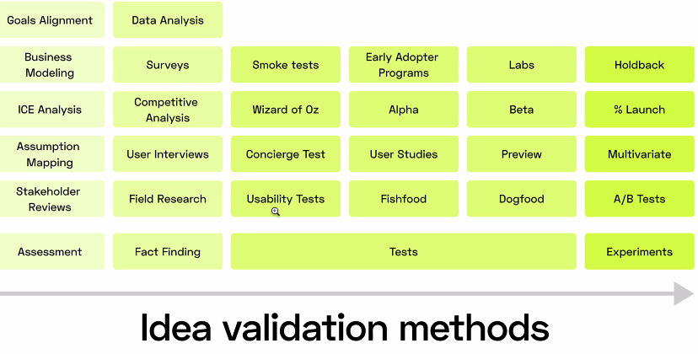

- Değer önerisi sun
  - Potansiyel müşterinin en rahat ve net anlayacağı bir dilde değer önerisini yaz.
  - Hedef kitlle ve onlara nasıl yardım edeceğini anlamayı sağlar.
- MVP hazırlı
  - Ürününü en basit haliyle çalışan hali.
  - Değer önerini test et.
  - Ön-ürün haline getir, il kullanıcılardan feedback al.
  - Kullanıcı, anket yap. Potansiyel kullanıcılar bulunca ürüne ne ekliyim nereyi değiştiriyim ile strateji üret.
  - MVP is a customer development tactic. Without any engineering waste and get your product in the hand of early adopters. Bir kere kullandı iki kere kullandı üçüncü kere kullanmadı. Kimse anlamadı kimse kullanmadı o zaman scrapliyorum diyosun.
  - 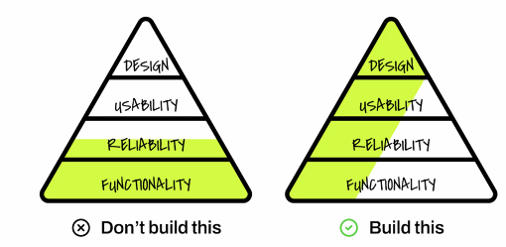
  - Functionality: Engineering, Reliability: Scalability, Usability: Learning curve, Retention, Design: Aesthetics

- Verileri incele (MVP beğenilirse komunite fonlıcak ve bu aşamalardan sonra yardım edecek)
  - Verileri incele, planını yap
  - İlk asıl para kazanacağınız alan burası.
  - Ayda 300-400$ kazanan android app storeunda appi varmış. 80k$ teklif etmişler. Demiş nasıl olur, 80 veren 250 de verir noluyor. Açmış analiz etmiş verisini, onu kullanarak şu an ayda 65k$ getiren appe dönüştürmüş. (En başta da upworkten 2k$a appi yaptırmış)
- Büyüme planı hazırlamak
  - Yeni müşteri getirmek
- Sürekli değerlendirme yap
  - Monitor et, ölç,
- 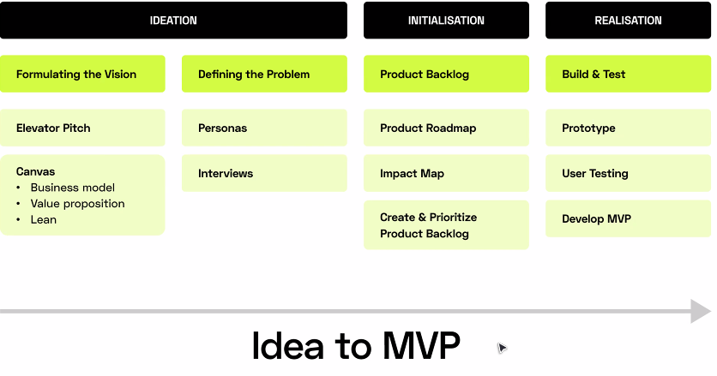
- Prodcut roadmap 0-2, 2-4, 4-6 haftayı nasıl geçiricem. +3,4 aylık pazarını büyütme pazarlama çalışması yapmak lazım.
- 6. Haftanın sonunda impact mapin olmalı impacti nasıl ölçücen ve geliştiricen.
- Product backlog: Bugün ne yaptım, neden yaptım, ne kazandırdı ne kaybettirdi. Her kararı niye aldım. (Notion: Startup OS mesela Fatih bedava paylaşıcak istE)
- Build & Test: Prototype (Mockup) -> User test -> Develop MVP (Build kısmı en son)
- Figma’da burden buna tıklayınca buna gitsin, burden buna tıklayınca buna gitsin diye visual app yapıp Figma’nnın mirror uygulamasını çalıştırınca app yapılmış gibi çalışıyor.

Product management
  - Voice of society: Müşteriyi dinlemek önemli.
  - Marketing: Marketing yapamazsan aynısının klonunu yaparlar önündeki parayı alırlar.
  - Business operation: Sorumluluk paylaşımı, hesap sorulması, deadline.
  - Customer success: Customer contactını iyi bir dille zekice yapman lazım.
- Top soft and hard skills
  - Stporytelling: Both to impress your team and your external relations.
  - Empathy: Get the motivations of others, play into that.
  - Whole product experience: Understand customer journey, initial discovery to purchasing implementation and retirement reduce friction in all.
  - Strategic alignment
  - Data insights
  - Discovery and validation
  - Customer value projection:
  - Outcome ownership:
- 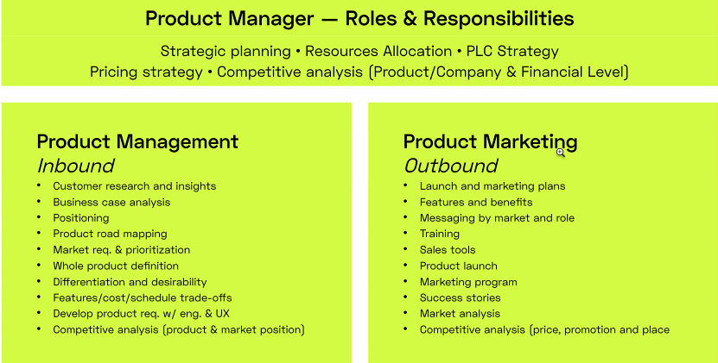
  - Product road mapping: 3. 4. 5. Versiyonlarda ne özellik ekleyeceğine bileceksin pazarın ne istediğini görerek.
  - Market prioritization: Daha olgunlaşmamış bir market olmaz çok ileriyi görsen bile zamanlamanı doğru yapıcan.

Personal Branding
- Gençken 1 1.5 yıl kişisel markanı craftlamak zordur ama ondan sonrası çok kolay!
- You can use your products to popularize your personal branding or use your personal branding to popularize your products. (If using products for PB start charging Money fort hem after 3-4 free ones.))
- Personal branding is being a content creator with your own name (not faceless) Personal branding will pay dividens throughout your lifetime and it sticks the amount of quality you put out on average to every new thing you do.
- Personal Brand: Skill + experience + personality THAT YOU WANT OTHERS TO ASSOCIATE WITH YOU.
- X projesini kapattın Y projesine geçtin X’I geride bırakıyorsun ama X yerine personal brandini kurmuşsan personal brandini yanında götürebilirsin.
- When a creator you will become rich because you are cranking content nonstop, period. And you won’t become rich otherwise. And depending on what it takes to create your content you can easily not have any time to spend your money Like for the hot ones think of the amount of research he has to go through every time. So automate it and you are golden. (Consistent content creation, and no time spent. Gotta go back on top of Lurien!!!)
- Pre-Step to Selling Digital Products. Allows for revenue in case of youtube, Instagram etc. OR Ana üründen önce ücretsiz ürün – Kendi communityni toplamak için hack -> Next product için reklam yapacak çok insan and with a conversion rate your future customers.
- Using products as a personal branding tool: TR’de genelde 1. 2. Dijital ürünlerini ücretsiz veriyorlar. Bir şey üretiyor işte excel dosyası bilmem ne, benle etkileşime gir sana exceli atıcam diyor o linkedin olayı, bedavaya veriyor. Dijital ürün büyük olmak durumunda değil initializing fanship ama tam fan olması için 2. Ürününü de alması lazım artık.)
- Yıllardır hep aynı şeyleri tutarlı bir şekilde söylüyorum ve düzenli bunların üzerine koyuyorum geliştiriyorum. Her daldan bir advice yazmaktansa mesela kızın sadece good man ilişkileri üzerine konuşması onu otorite yapıyor. Bir güni lişkiden bir gün hayat amacından bahsetse dinlemezdim.
- Normally part of marketing but takes some time to get traction therefore it requires you to start early. Very useful for selling anything, nearly necessary for selling digital products. Full Stack Creator= Personal Branding + Community Development & then Product Development & Selling. (You do all in that order)
- Gelir modeli reklam olduğu sürece digital platform klansmanında. (Sponsored reklam veya youtube ads vs.)
- To grow a customer base, it will soon become essential for brands to engage their communities— Community based ideas are becoming NECESSARY
- Bunu yapınca sen bir ürün ürettiğinde satılacak sana bir güven oluyor hem de bir talep oluyor. Alternatif olarak profesyonel olarak makale filan publishlemiş olmakla aynı hesap. JESUS. Akademik yetkinlik ve public authority günümüzde aynı kefede. (HALO EFFECT)
- Güvenilirlik (Kalite x Yineleme (Günde çok post) + Özgünlük (Başka hiçkimsede olmayan basit, net içerik) =Takip
- Sosyal medyada içerik üret, bir yandan da bedavaya ürün vererek kitleni kas. Kitlen beeli bir noktaya gelince ürün validasyonu yap anketlerle sonra ürün ççıkarıp yine kitlenden başlayarak sat..
- Retirement: Bi noktada creatorlar ürünleri tutunca ürünleri üzerinden tanımlanıp “famous” oluyorlar content üretmiyorlar sadece yorum yapıyorlar.
- 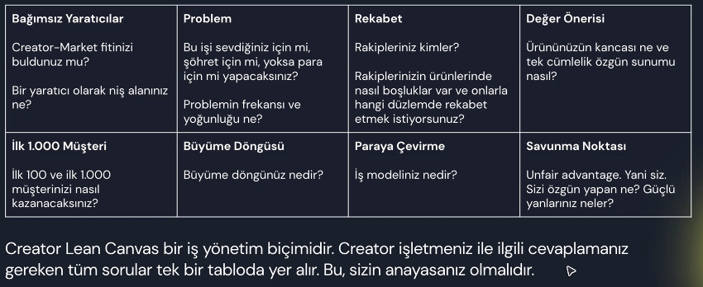
- Problemin frekansı? Günde bir mi çözüm lazım, 2 ayda bir mi?
- Rakipleriniz kimler, onların boşlukları eksikleri ne? Onları yap.
- Büyük rakip hantal olur, onların olamayacağı, olmakta zorlanacağı yerlere sızarsın.
- Example Funneling Guide:
- 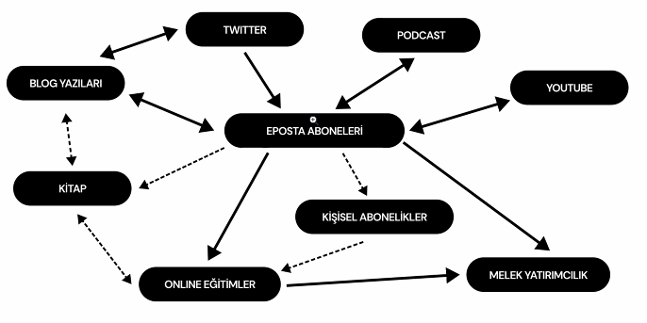
- 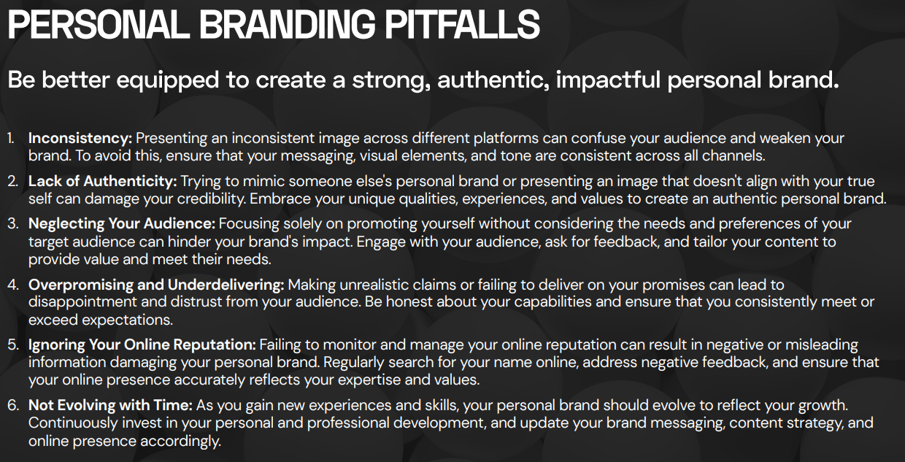
- 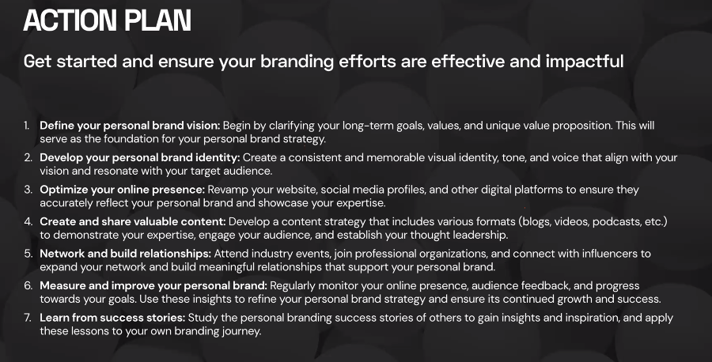

Brand Identity
- Brand identity (UVP’nizi, kişiliğinizi ortaya koyup unutulmamanızı sağlıyor)
  - Visual branding. Name, logo, profil fotosu, slogan, color scheme. Professional, eye catching, aligned with your brand personality, Her yerde tutarlı bir şekilde olmalısınız.
    - Twitter hesabında profesyonel bir iletişim yapmaya çalışıyor ama insta hesabı kilitli mesela. Olmaz.
  - Tagline or slogan. Develop a catchy tagline or slogan.
    - Ex: Once you become fearless, life becomes limitless.
    - UVP’nizi, uzmanlığınızı, misyonuzu belirtmeli özetlemeli bu tagline.
  - Tone and voice
    - Tüm konuşup yazdıklarınızın benzer bir dilden yazılması lazım.
    - Fatih mesela heyecanlı bir insan, ona bunun kötü bir şey olduğunu düşündürüyorlarmış. Oysa benim heyecanım beni ben yapan şeylerden birisi demiş. Heyecanına sahip çıkmaya başlamış.
    - Stand up for yourself without being a dick demiş mesela kadın. Ama onun anlatımına, yeri gelen wittyliğine argosuna uygun o yüzden kaba kaçmıyor.
  - 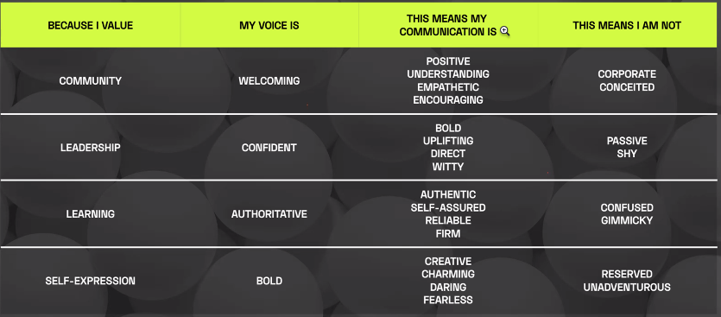
  - ^ Benimki learning ve self-expression mesela, use that!!! One of them or both of them. Seçmek zorunda değiliz burden, bunun gibi original bir şey yapılmalı.
  - Personal story
    - Craft a compelling story that highlights your journey.
    - Her yerde aynı şekilde anlatılması lazım.
    - Belli instancelar ve anektotlar aynı şekilde anlatılmalı.
    - We are all made of stories.
    - Üniversiteden atılmış olması mesela Fatih’in hem sahip çıktığı hem sahip çıkılan bir şey.
  - Tüm platformlarda tutarlılık!
    - İki farklı twitter olmaz.
    - Aynı biçimde ama farklı formatta:
    - Twitterda vurucu kısa, linkedinde uzun anektotlar tutuyor mesela.

Social Media General
- Content Types
  - Eğitim
  - Merak
  - İlham
  - Eğlence
  - 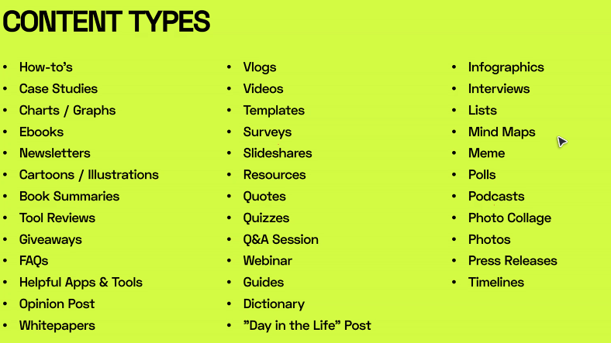
- Reaching People (Less to more direct)
  - Nothing (Kendi followerlarındaki like ration kadar like alıyosun yeni follower almıyorsun)
  - Hashtags (Baya daha çok hesaba ulaşıyosun, farklı bir like ratiosu kadar like, bir follow ratiosu kadar follow alıyosun)
  - Discoverability networks: Reddit, Imgur, Pinterest
  - Cold Calls
  - Collobaration
- 500 gün frameworkü – Twitter merkezli
  - Şu anda Türkiyede X konu üzerine uzman olacaksın. Hangi konuyla ilgili uzman olmak isterdin? Cevapla->
  - Her gün kriz yönetimi ile ilgili kitap içeriği sayılabilecek 3-4 tweet atılmalı. Kuru bir dille yazılmamalı, özgün bir dille invigirating yapılmalı. (ChatGPT mesela kuru içerik üretiyor, insanlık katmak, anektot, fikir katmak lazım mesela))
  - Her gün bu içeriği yazarken, bir yandan da X konu üzerine tweet yapan insanlara cevap vermeli mention yapmalı. Karşı mention gelirse cevapla geri gitmeli engaje olmalı.
  - Retweet yap bu tarz insanları günde 2-3.
  - İçerik üret, mentionlaş, retweet yap.
  - Hayatın içinden insanları gülümsetecek 1-2 ince görülmüş anektot paylaşmalı.
  - + her gün aynı X konuusyla ilgili 1 kişiyi daha takip et.
  - 500 gün boyunca bunu yaparsan Türkiye’de bu konuyla ilgili ıuzmanlardan biri haline geleceksin. TV’ler, YTler, dergiler, üni kulüpleri seni çağıracaklar. Markalar sana workshop için çağıracaklar.
  - Ve 500 günden sonra artık habit haline geldiği için zoruna gitmeyecek.
  - Ve en başta bu işi anlamış olmasan da o takip ettiğin insanlarla, münazaralarla zaten 500 günde de öğreniyorsun, uzman oluyorsun.
  - OG Paylaşım (Content) + Mention People (Inter outbound) + Retweert People (2-3) (Inter outbound) + Answer Peoples tweets (Inter Inbound) İnce Anektot (0.1-0.2) (Content) + Follow 1 new person (Inter outbound) + read everyday to be able to curate more content (Content premove) in your niche every day
- İzlenecek yol
  - Kendi kitlesini geliştirmek – Must do. (ELZEM) – Birebir kendi markanda olmak zorunda da değil ama çok uzak da olmasın.
  - Uzmanlığını paketlemek, başkalarına öğretmek.
  - Networking and engagement. Bütün mesajlara, mentionlarına yardımcı ol. Senin 10dk yardımcı olabileceğin bir şey istiyorlarsa yap o san 10 kişi getirir. 1 değil 11 kişiye ayırıyosun o zamanı. Online tartışma , m,nazaralara katıl. İnsanları tahrik edecek düşündürecek sorular sor. Etkinliklere girr markanızla ilgili.
  - Son olarak da kitleye bir ürün sunuyorusn.
  - Yeteri kadar iyi olmadığını bilseniz bile aynı konuyla ilgili 100 içerik üretebilir misiniz? İşte self motivation buradda devreye gidiyor. Bilgisi çok sığ sularada yüzen adam bile düzenli olduğu sürece bir yere geliyor.
  - Büyüme döngüsü:
    - Girdiler: Yeni ve dönen müşteriler.
    - Aksiyonlar: Müşterikleri tutmak içnin sunulan değerler
      - 100 değil 120 tweet yaz
    - Çıktılar:
      - Görüntülenme 1M’den 1.4M e çıktı.
      - %20 more work %40 more growth ise buna göre hamle yap.
  - Yeterince içerik olunca feedback alabilirsin, nelerin çalıştığını anlayabilirsin. (Çok içerik üretmek bu yüzden önemli)
  - Biz var olan pazarda yeni ürün yapmak istiypruz neden?
    - İyzico mesela
    - Abonelik ödeme veri yolu varmış. Subscription aktarma modeli.
    - İyziconun yaptığı diğeri şleri bırakıp sadece subscriptionına rakip ol.
    - Idea validationu zaten iyzico yapmış.
    - DAVID & GOLIATH YAPMAK ISTIYORUZ. SLAY THE BEAST.

How to write for engagement?
- Yazma yeteneğimi nasıl geliştirirrim
  - Okumak
  - Yazma pratiği yapın
  - Yazınızı planlayın
    - Vermek istediğin mesajları cümle cümle yaz
    - İnsanların araştırmasını istediği terimleri yaz.
    - Etkileşime kanıt ara, twitter poll etc.
    - Ara başlık kaldırır mı demeç almam gerekiyor mu
  - Basit bir dil kullanın
    - People don’t read on the internet they skim.
    - 7 kelimeyi geçmeyen cümleler
  - Rötuşla yazıyı, hece, grammer. (Özensiz görünürsün yoksa)
  - Dikkat et
    - Kitleni tanı, senin hangi sinyallerin onların hangi ışıklarını yakıyor
    - Görseller: Göz alıcı ve özgün. Stock photo filan olmaz.
    - Anketler yarışmalar gibi etkileşimi çok paylaşımlar yapın.
    - Fırsat bulduğunuz her yerde hikaye anlatın
    - Hashtagler içeriğin bulunabilirliğini arttırır.
    - Tutarlı frekansta paylaşım yap. – Algoritmalar bunu öne çıkarıyor.
    - Kitlenizin mesaj ve yorumlarınla engageleyin.
  - Özgün ve Etkili başlıklar yazın (First line of defence)
    - Dikkat çeken başlıklar kullanın (Clickbait) Secret, proven, unbelievable
    - Kısa ve hedefli yazın. 70 karakterin altında olsun.
    - Bilgilendirici olsun başlık. Okuyucuya içerikle ilgili net fikir versin. Okuyucuyu 1 kere kandırabilirsni iki kere kandıramazsın.
    - Rakam kullanın, 10 tips to… , rakamlar dikkat çeker
    - Esprili olun veya kelime oyunu yapın
    - Soru sorun
      - Ama açık uçlu da senden güzel cevap verip senin sırtını yere getirebilir
        - Bu işe yarafdığını biliyor musunuz?
        - Bilmiyorum ya anlatsana gibi aptalca bir yorum almamalısın.
      - 2 cümle. 1. Cümle soru, 2. Cümle ünlem. C vitamminin başağrısına iyi geldiğini biliyor musunuz? C vitamini kullananlarda başağrısı %65 daha az oluyor!
      - Pull & Punch
    - Duygulara hitap edin
      - Duygu uyandırırsa başlık bütün metni okurlar.

Social Media Specific
- Twitter
  - Hesap tipleri
    - Bildiğin bir şeyi anlat (Eğitim)
    - Bilmediğin bir şeyi sorarak etkileşime gir (Merak)
    - İlham aldığın insanların içeriklerini paylaş (İlham)
    - Olan şeyleri duyur (Haber)
  - Fatih’in dediği sürekli bu konuda kitap okuyarak hem kendini hem profilini doldurmalısın çok iyi sürdürülebilirlik tipi.
  - Steps
    - Pick 3 Main content bucket
    - Pot 3-5 times Daily
    - Make categorized list for people you follow that has at least 50k followers.
    - Create a weekly tweetstorm
    - Engage with people everyday
    - Learn (Read) everyday
    - Build in public
  - Dikkat et
    - Kitleni tanı, senin hangi sinyallerin onların hangi ışıklarını yakıyor
    - Görseller: Göz alıcı ve özgün. Stock photo filan olmaz.
    - Anketler yarışmalar gibi etkileşimi çok paylaşımlar yapın.
    - Fırsat bulduğunuz her yerde hikaye anlatın
    - Hashtagler içeriğin bulunabilirliğini arttırır.
    - Tutarlı frekansta paylaşım yap. – Algoritmalar bunu öne çıkarıyor.
    - Kitlenizin mesaj ve yorumlarınla engageleyin.
  - Özgün ve Etkili başlıklar yazın (First line of defence)
    - Dikkat çeken başlıklar kullanın (Clickbait) Secret, proven, unbelievable
    - Kısa ve hedefli yazın. 70 karakterin altında olsun.
    - Bilgilendirici olsun başlık. Okuyucuya içerikle ilgili net fikir versin. Okuyucuyu 1 kere kandırabilirsni iki kere kandıramazsın.
    - Rakam kullanın, 10 tips to… , rakamlar dikkat çeker
    - Esprili olun veya kelime oyunu yapın
    - Soru sorun
      - Ama açık uçlu da senden güzel cevap verip senin sırtını yere getirebilir
        - Bu işe yarafdığını biliyor musunuz?
        - Bilmiyorum ya anlatsana gibi aptalca bir yorum almamalısın.
      - 2 cümle. 1. Cümle soru, 2. Cümle ünlem. C vitamminin başağrısına iyi geldiğini biliyor musunuz? C vitamini kullananlarda başağrısı %65 daha az oluyor!
      - Pull & Punch
    - Duygulara hitap edin
      - Duygu uyandırırsa başlık bütün metni okurlar.

- Youtube
  - Tell stories, entertain or teach
  - make 100 videos and improve something each timee
  - it's ok for your niche to evolve over time, do what you like
  - Ask them to watch another video
  - Curiosity in title: 1.7M New York Loft, Best NY Loft, I found the best NY loft.... but no body wants it
  - Probe curiosity and tell you’ll explain that in the first 20% and explain it at the 80% mark.
    - (People will watch the 20% regardless s they’ll hear it after being peaked they’ll watch until they get an answer, after they get the answer small amount of vid is left so they finish iyt)
    - https://www.youtube.com/watch?v=g0amdIcZt5I&ab_channel=Veritasium

Using Personal Brand for Product Research
- Product personal brandle alakalı olmalı ki insanlar senin expertizini kullandığını görsün.
- Önce gelecekte ürünümüzü alma potansiyeli olan kişileri çevremizde toplıcaz
  - Fikir validasyonu için, talep miktarı,
  - Geri bildirim toplama
    - Örnek to do list yapma fikri var aklında.
    - Gidip en çok kullandığnız to do listleri gönderir misiniz diyip anket yapıyosun
    - Sonra 1. Fikrin şöyle bir özelliği olsa nasıll olur diye soruyosun
    - Feature talebi, geliştirme alanı (feature sayısı azsa hemen bitiriyor, nereye gideceğini bilmek de çok önemli)
  - Mesajlama
    - Hangi pazarlama mesajları daha iyi çalışıyor hangileri çalışmıyor
    - Metinlerini test ediyorsun
    - Pazarlama stratejisi geliştiriyorsun
  - Otorite oluşturma
    - Ürünü satma vakti geldiğinde senin ismin çoktan çıkmışsa o senin ürününe de güvenilirlik veriyor
  - Kitle fonlama (Ön satış)
    - Ürünü öyle yazdın ki, ürün henüz yok ama 60 gün sonra gelecek bugün almak istersen 29 $ a alabilirsin ama 60 gün sonra 99 $ olucak
    - Crowdfunding yapabilirsin
  - Community building
    - Ürününüz etrafında çalışan, ürünü başkalarına anlatan ve perpetual etkileşim sağlayan bir topluluğunuz olur

Communication Channels Discovery Index
- 5/5 Recommends new content to non-followers
  - Imgur
  - Reddit
  - Pinterest
- 4/5 Uses algo to recommend to non-followers (Also recommend low clicked content)
  - Youtube
- 3/5 Also uses algo but not as in face. Requires multiple steps (Go to discovery and not reels etc., recommends already popular content
  - Instagram
  - Tiktok
- 2/5 Your post should be “reposted” through your connections, only your connections see it otherwise
  - Twitter
  - Linkedin
  - Facebook
  - Tumblr
  - Mastadon
- 1/5 Requires direct connection to your content
  - Own Website (Generator)
  - Twitch

Digital Products (documents, online Courses, video, audio , music, graphics, photography, eBooks, software, applications)
- Content Creator
  - Online course
  - Membership Site
  - Downloadable Guides
  - Exclusive Video
  - Podcasts
  - Ebooks
- Fitness Coach
  - Online Course
  - Online community
  - Paid newsletter
  - Meditation audio
  - Workout bideo subscription
  - Welness Tracker
  - Workout plans
- Online Learning
  - Ebook
  - Tutorials
  - Online courses
  - Membership sites
  - Workshops
  - Checklists
  - Certified courses
  - Home recipes
- Hair and makeup tutorials
- Small businesses
  - Business podcast
  - Resume template
  - Cover letter template
  - Media kit template
  - Legal template
  - Pinterest template
  - Power point template
  - Brochure template
  - Email sequence template
  - Career ebook
  - Goal setting printable
  - Apps
  - Video games
  - Website themes
  - Browser Plugins
  - Codes
- Artists
  - Art video tutorials
  - Digitl art
  - Patterns
  - Wallpapers
  - Fonts
  - Brushes
  - Icons
  - Backgrounds for video chats
  - 3D printer design files
  - Animations
  - Instagram story templates
  - Fiction ebooks
  - Publishing guides
  - Writer’s community
- Foodies
  - Meal prep plans
  - Recipe ebooks
  - Digital cookbooks
  - Online cooking course
  - Food tracker printables
  - Kitchen conversiopn printables
  - Recipe binder cover
- Musicians
  - Custom Songs
  - Sound Effects
  - Instrumental Tracks
  - Beats
  - Music sheets
  - Online music courses
- Faith based Creators
  - Faith ebooks
  - Devotionals
  - Bible study guide
  - Planners
- Kids Creators
  - Printable games
  - AUdiobooks
  - Activity rintable
  - Trip guide
  - Drawing printable
  - Oline art school
- Photographers
  - Presets and filters
  - Stock photos
  - Video intros
  - Stock video
  - Photo and video courses
  - After effect templates
  - Mockup images and videos
  - Calender with photography
- Tech
  - Website plugins
  - Website templates
  - Software
  - Code snippets
  - Hosting
  - Video games
- Writer
  - Ebook
  - Spin offs
  - Short stories
  - Fanfic
  - Publishing guide
  - Novel planning Sheet

Good Websites
- Exploding Topics – What is going to trend?
- Canny – Güzel geri bildirim platformu
- Hotjar – Kullanıcı senin siteni nasıl kullanıyor? (Sormuyor observelüyor, design thinking açısından çok değerli)
- Supernova – Easy css etc. May be needed to streamline website, looks pretty efficient.
- Checklist Design – Bu değil de sanki komunitenin daha iyi checklist resourceları vardı asıl onları kullanalım. (Komunitenin resourceları gelene kadar bu dursun)
- Lottie – Animasyonlar için çok güzel bir toola benziyor. Her şey videoya/reele/tiktoka gittiği için bu aralar baya iş görebilir orijinal içerik üretmekte. Ama yine de animatör olmak zor iş opportunity costuna bakılmalı.
- Pipedream – Scraping için çok ideal bir no-codeumsu tool. Kullanılabilir.
- IFTTT – Tek bir postla birden çok platforma (post insta post as twittter post) postlamak gibi otomasyonlar sunuyor. Lazım ve kritik. (Belki posting değil sadece scheduling vardır bu bir control edilsin.)
- Make – Business automation için lazım. Lead centralization ve distribution için önemli.
- Appsmith – Internal toollar yaptığımız işi streamlinelamak ve bir şeyleri unutmadan çalışmak için çok kritik, bunu no-code sunuyor, başarılı
- FlutterFlow – Tam flutterla kendime tool yazmayı öğrenecektim çok zamanında geldi. Hem cross platform hem no-code, bayıldım direkt başlıyorum.
- Hemingway – Yazı bazlı içerik üretmeye başladığımda (Ki geçen haftadan görünen o ki başka türlü içerik zaten yok (Ben fotoğraf üretiyorum gerçi de mühim değil)) çok faydalı olur.
- Appsumo, ProductHunt – Bu tarz ürün satma/tanıtma siteleri çok önemli!
- Netpeak Spider – SEO severiz, çok underrated bi tool.
- Black Magic – Twitter analytics, güzel.
- Buy me a Coffee – Ben Ko-fi açmayı düşünüyordum bu daha iyi imiş.
- Stripe – Ödeme altyapısı, kritik!
- Summari – Web sayfası özetleme -> content creation automatelenebilir
- Buffer – Tüm social medialar için scheduler ve analyst, lazım!
- Sparktoro – Audience analytics
Zaten Kullandıklarım
- Stock photo, video, font siteleri
- Photo editing siteleri
- VS Code
- Kendim websitesi yazıyorum o yüzden bunun no-codelarını pas geçtim (Şimdillik)
- Google Analytics

How to Find and Solve a Problem?

Footnote on Finding a GREAT Problem
- I understand it know
- how an entrepreneur's job is to imagine the future
- it is not about the area
- apple, windows and amazon are all the same
- tesla, facebook and airbnb are all the same
- like Sbari Hoca said, you need to be global to win a nobel
- you need to touch everyone on the planet to build one of THE startups
- technical knowledge is necessary only enough to realize your vision
- facebook looked like crap by todays standards
- it was the idea that counted
- the convenience the want of people to use it
- take today's technologies and put it in a basket
- whatever you pick from it won't be the next big idea
- entrepreneurs don't find ideas
- they create them
- an idea to touch every single person on this earth
- before apple, the idea of a pc was not around
- you need an idea that is revolutionary
- disruptful
- that will kill many industries to birth a new
- the queen is dead long live the queen
- DISRUPTFUL TECHNOLOGİES
- 3D printing
- 5G
- AI
- Robotics
- As a service computing
- Disruptful tech: The Innovator's Dilemma 1997, product with mass appeal
- Entirely new way of getting something done
- Established companies pursue incremental improvements on things they know works
- Superseeds older process, product, habit
- Superior attributes that are immediately obvious
- warren buffetiin end year bi şey okumasından şirket seçmesi gibi öldürecek sektör seçilebilir
- berkshire hathawat annual reports
- I shall disrupt what I know
- I know engineering
- Robotics
- Find Problem, solve it, sell it
- (Can it be that simple)
- Sub-system geliştirmek de iyi para
- elektrikli motor satmak mesela marifet
- Kill automotive?
- Industrial Robotları diruptla?
- Esnafları disruptla
- amazon yapmış onu al sat yapmak yerine komisyon alarak aynı işi yapıyor.
- bütün küçük esnaflar bugün batsa
- onların yerine ne mağazası açmak mantıklı
- "Customers can’t tell you what to do. Build what you want and then sell it after"
- "Be unique and highly valuable at the same time. Then, you don’t have to compete with price, either."
- Bonus Rule from Guy Kawasaki
- 11) Perfect your pitch
- This will separate you from the pack of people who don’t “get it” and align you with the people that do “get it.”

- You should be striving to build giants.
- Notice that cars, planes or even microchips are not considered tech
- These are not tech companies these are industries
- So what is the difference?
- SCALABILITY
- You can scale your software or design based business practically overnight
- But it take A LOT of time to scale up any industry based sector
- So it is VERY logical to start in TECH
- Robotics in general can be both tech (DJI) or industry (UAV)
- It is divided depending on the end user
- If your end user is ordinary people you are more inclined to Tech, if it is a government or other industrialists you are in industry
- S
- Startup ecosystem lazım, tax laws lax olmalı, geography de localin büyük olmalı. Yunanistanda çıksa 10M insana ne yapcak adam. Dolayısıyla USA’e yapıyosun.
- Tüm Avrupa'ya yapsan da 30 dile çevirmen lazım önce

Physical vs Digital
- Physical
  - What you produce should be apocalypse proof. Aka it should be material and strong. Next year the whole internet may chrash but every single penny in my pocket will still be there while 3000 hours of dota play will suddenly have no meaning
  - Always emphasize the need for a product that is not hackable. Digital and electronic components should be used at a minimum and if possible,non
- Digital
  - I am looking for something I can actively prototype in. (Digital iyi)

What is there to produce?
- You cant produce a plane straightaway.
- You can produce parts of a thing
- You can produce apps or optimizations
- Stocks can be identified as long term investments, that pay off in short term only with spikes and careful social engineering
- You need to be a good engineer to design and produce products and production means.
- It is more profitable to produce your mass production machines. Which are usually robotic arms.
- It is also profitable to do fundamental businesses such as agriculture on a mass scale. It would be good means of money to start off by doing that as a passive income.

How to Isolate a Problem (Design Thinking) FUI
- Your ideas should start from problems or opoortunities not solutions.
- ÇÖZÜMÜN ARKASINDAKİ SORUN DOĞRU TANIMLANMAMAIŞSA O ÇÖZÜM ÇÖP OLUYOR
- Fırsatların kaynağı nedir
  - Pazar boşluğu (Talep)
  - İhtiyaç
  - Sorunlar
  - Gözlem
  - Farkındalık
  - Vizyon, öngörü
  - Hayal
  - Merak
  - What if?
  - How might we?
  - Keşke şnula ilgili çözüm olsa.
- Look at problems
  - Look at popular, growing markets
  - Look at urgent problems. (Start of the COVID pandemic is a very good example)
  - Look at expensive problems. (That requires billions of dollars. Solve them if they are not solved (C-level consultancy firms were a good example back in the day) or if they are being solved for billions find a way to solve them for cheaper. (Musk sending rockets at one tenth the cost))
  - Look at mandatory problems. (Man’s gotta eat.)
  - Look at frequent problems. (Problems you come across multiple times a day)
- Don’t start from the solution: “There is this new tech I want to do something with” <- NO! You won’t be able to drum up a problem. You need the problem, the solution can be anything.
- Selling is helping not convincing -Mark Cuban
- To me individual behaviour is much more logical and understandable then collective behaviour. That s why I dont develop tech for the collective. The upside of this is solving individual problems are harder and solutions are sold for higher price tags. The downside is of course there are less individuals with problems then collective's problems. A great idea should start from an individual's problem but when you try to scale it to the collective it should be the collective's problem too. That is how you know you struck gold with your problem and your solution. Therefore get to know individuals and get to know their problems. Then see of which's solutions are infinitely scalable to the collective. That is your metric of having found the right problem. -MÇS

- Biz yeni bir ihtiyaç yaratmıyoruz. Olan ihtiyaçları karşılamanın daha iyi yollarını bulmaya çalışıyoruz. (İnsanların farkında bile olmadığı ihtiyaçlar)
- 20. Yy normu = Verimlilik (Do the same thing 1x, 2x)
- 21. Yy. normu = Yıkıcılık (BE DISRUPTIVE, do it 10x, 20x)
- Başarılı inovasyonlar ihtiyaçlara çare olur. Fikir düşünmek yerine sorunları fark edin! İnsanların istediğini anlamak bir şey yapmaktan daha zor!!!
- Design Thinking: Anla-Gözlemle-Tanımla-Fikir Üret-Prototiple-Test Et

Anla
- Design Thinking: Anla-Gözlemle-Tanımla-Fikir Üret-Prototiple-Test Et
- Know that things are not what they seem
  - Sorun ne şu an nasıl çözülüyor, bizim çözümümüz niye daha iyi
  - İnsana sorunca anlamak zor, derindeki düşüncelerini hislerini açığa kolay kolay vurmazlar.
- Why do we do the things that we do
- Instagram narsisizmi twitter iletişim ihtiyacını gösteriyor

Gözlem = Mülakat (Find all the things that are not seen)
- Gözlem gerçeği söyler, asıl o derindekini görürsün insanların söylemediği ama düşündüğünü gösterir.
- Anketler doğru soruları bilidğinizi varsayar, doğru soruları sorabilmek ve insanların o derinde tuttukları isteklerini bulmak çok zor bir iş. Derine girmen için senin o adama 5 saat anket yapman lazım gittikçe derinleşen.
- (%80 alırım güzel fikir, %10sa çöp)
- Gözlemde amaç zorlukları, sürprizleri, gerginlikleri bulmak. Bizi doğrulayacak bilgiyi değil bizi çürütecek bilgileri aramalı onları çözmeliyiz.
- Gözlem: Adam PC adaptörünün ısınmasıyla kahve ısıtmaya çalışıyor. Sorun: Kahve soğuyor, adaptör çok ısınıyor. Veya laptop kameraları üzerine bant çekilmesi artık kapaklı yapılıyor.
- Gözlem yapmak için iletişim kurmak, insanların olduğunu bilmediği sorunlarını çıkartmak lazım bu da mülakat ile yapılacak: (Sonucunda bir problemler listesi edin)

Beating the fear of rejection (Rejection Therapy))
- Nobody likes to get rejected and the best way to overcome this is to get desensitized to it.
- You will come across rejection everywhere. While you are trying to interview people to when you are trying to sell your product.
- It is essential to not be afraid of rejection to simply function in an entrepreneurial environment.
- Go outside ask for ridiculuous things, ask for a free coffee at starbucks, ask for a free hotel room for the night, ask to be driven around in a sports car for free. Go nuts and don’t forget the aim is to GET REJECTED. So if you don’t get rejected it doesn’t count, try again.
- VERDICT: With the right delivery (kind, respectful), there is no downside to asking for things. So don’t be afraid to ask for things from people, your life can only go up from there.

Communication M + How to Talk to Humans
- Her zaman söylediklerimize karşı bir feedback almak lazım karşıdan. Algılama ve ifade etme farklılıkları var to be on the same page always ttake feedback when expressing thoughts.

Mülakat Nasıl Yapılmalı?
- Duymak istediğiniz şey davranışlar.
- Böyle bir şey olsa alır mısın değil. Çok kötü soru. Bizce şu sorun var sen ne dersin değil. Davranış duymaya çalış gerçek onların sorununu bulmaya çalış.
- Açık uçlu soru sor
- spekülasyon yapma (Sence küresel ısınma problem mi tabi evet dicek)
- Hikaye dinlemek istiyorsunuz. Çöpünü çöpe atıyo musun? Çöp kutusu dolu. Çöp kutusu dolu olunca napıyosun? Deş ve hikayeyi davranışı çıkar oradan.
- Konuşmayı yönetin
  - Şu X durumda ne yaptın?
  - Bununla ilgili olay anlatır mısın?
  - Neden veya nasıl yaptınız bunu? 5 KEZ Yinele.
  - Bunda en çok neyi sevdin/sevmedin.
  - Bir sihirli değneğiniz olsaydı, kampüste hangi sorunu çözmemizi isterdin veya ne yapardın?
- Mülakatları 3’erli yapın. 3 mülakat yapan kişi.
  - İlişki kurma cümlesini çalışın Biz projede çalışıyoruz vs. diye gircen)
  - Ortak bir konu (hava)
  - Farklı açılış cümleleri
  - Siz sadece %10 kadar konuşum
  - En az 2 kişi, 1 kişi not tutsun, 1i sorsun
  - Tazeyken sizi şaşırtanları yuvarlak içine alın.
  - Çok iyi konuşan birini yakaladıysanız contactını alın bir iletişim kurun bir daha gerekirse.
  - Değişik bir insan bulursanız onun gibi bir arkadaş
  - Konu hassas olmasa bile yüz yüze yapılması çok daha makul.
- Anlama ve Gözlem: Geniş düşün, meraklı ol, karşınızdaki ile empati kurun.

Tanımla (Sieve the problems that matter)
- Sorunu doğru tanımla. Sorun koronaysa sen pandemiyi biitiremeszsin. Ama sorun pandemide iletişimsizlikse o daha iyi
- En çok şaşırtan veya en çok duyduğumuz pronlem Öne çıkanları hangi derdi daha çok duydunuz bunlar ne anlama geliyor, yourmlayın
- Çok duyulanları, güzel cümleifade ve sseni şaşırtanları döküm ypın
- Persona oluşturun: Bu problemi kim yaşıyor, ne yapmaya çalıştığı için yaşıyor, nasıl biri.
  - Persona=Mülakat edilen kişinin profili
  - Şu yaş grubundan insanlar, böyle hayatlar sürüyorlar
  - Hedef odaklı persona: Tipik bir kullanıcım üettiğim ürünle ne yapacak. Kim faydalanacak kimin işine yarıcak
  - Kimi belirleyince, çözümü belirlemek için de güzel bir soru.
  - Senaryo: Hikaye anlat. Böyle ürünüm var, günümde ne zaman niçin bi insan bunu kullanıyor ve o günü o hayatını nasıl değiştiriyor.
  - Rol tabanlı persona:
  - Engage the personas. Çözüceğimiz probleme sahip olan kişiyi materyalleştirmek için persona yarat.
  - Fictional persona da yaratabilirsin tabi.
- How might we?
  - Çözümden başlamıyosun önce soruyu farklı şekillerde baştan tanımlıyorsun, soruda zenginlik yaratıyorsun:
  - Önce soruyu genişlet, sonra içgörü ile gözlem ile vs. daralt. Daralttığından geri genişlet, geri daralt etc.
  - 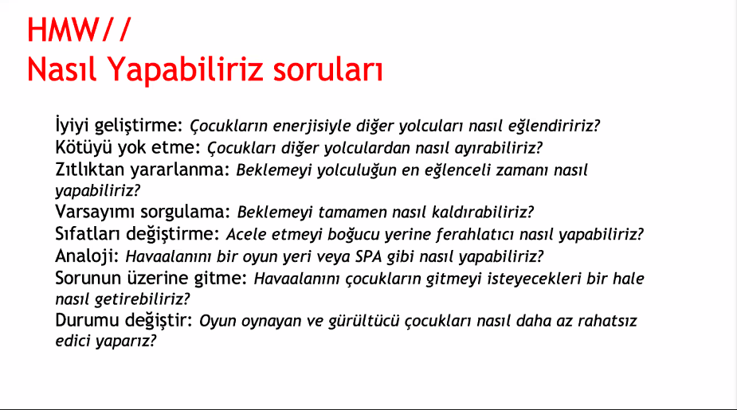
  - Problemleri bulduk.
  - Problemleri gruplara ayır, her grubun unique bir başlığı olacak
  - Her grubun sorununu bir how might we …? Şeklinde yaz.
  - 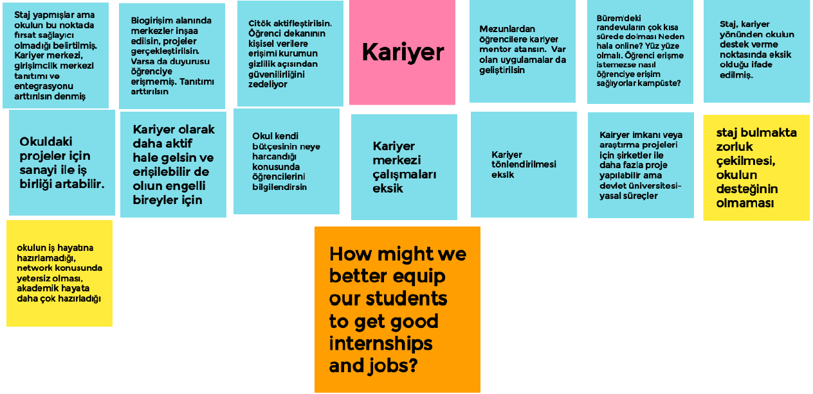
  - Bu how might we işte senin problem yazımın.
  - Chosen HMW: How might we better equip our students to get good internships and jobs?
    - We were surprised to notice ___ (interesting observations/quotes from the interview)____ Unanimous olması.
    - We wonder if this means ____(inference about the observation)___
    - How might we.....? (question based on the inference above)ve bunu da Jamboard içerisinde belirtiyoruz.
  - Initial feedback
    - Uzun vade kariyer guidanceı da güzel olur kısa vade sadece şiş bulmaktansa hayatını nasıl yönlendirmek istiyor?
    - Line of stajlar belki, biraz da haberleşme, mutabakat, takım olarak staja gönderme belki?
  - Empathy Map
    - Who is the person we want to understand?
      - Someone looking for a first job or internship.
    - What is the situation they are in?
      - They need to find an internship to graduate.
      - They need to find a job for after graduation.
      - They are under constant pressure to balance other things in their lives with the job hunt.
      - They are under pressure from their parents to find a job/internship.
      - They keep hearing about jobs and internships their friends have found.
    - What is their role in the situation?
      - They are the candidate in a sea of candidates.
    - What do they need to do differently?
      - They need to outshine the competition.
      - Their CVs need to match job offerings constantly with keywords.
      - Their experience must be relevant all the time.
      - They must have showable past work in the field.
    - What jobs do they want or need to get done?
      - They need to keep up with their classes
      - They want to get into their applications
      - They want to have an easy selection process
    - How will we know they were successful?
      - They get the intenship/job they wanted.
    - What to they see in the marketplace?
      - General application platforms: Staj seferbirliği, vizyonergenç
      - Specific application platforms: www.company.com/careers
    - What do they see in their immediate environment?
      - People who are getting jobs
      - People who are getting internships
      - People who don’t care if they get a job/internship right away
    - What do they see others saying and doing?
      - Since it is a competitive environment, they are probably not seeing anything.
    - What are they watching and reading?
    - What have we heard them say?
      - They are stressed
      - Çok iyi X üniversitesinde okuyorum, iş bulmak benim için de bu kadar zor olmamalı.
    - What can we imagine them saying?
      - Keşke tek bir tane başvuru sistemi olsaydı.
      - Çok stresli süreç, her aşama arasında çok fazla bekleniyor.
      - Sonuçların açıklanma süreleri arasında çok fark var, hangisini kabul ya da reddedeceğini bilemiyor.
    - What do they do today?
      - Classes, studying, chilling, repeating.
      - What behavior have we observed?
      - Very anxious, stressed about their future
      - Annoyed that their school education isn’t enough to get a position
    - What can we imagine them doing?
      - Getting paralyzed under the workload
      - Applying to tens of positions constantly
      - Constantly revising their CV, application letter, documents.
      - What are they hearing others say?
      - I got a job
      - I am applying to here
    - What are they hearing from friends?
    - What are they hearing from colleagues?
    - What are they hearing second-hand?
    - What are their fears, frustrations and anxieties?
    - What are their wants, needs, hopes, dreams?

How to Isolate an Initial Solution (Design Thinking) FUI BAZI YERLERDE ÜRÜN DEDİK BU CHAPTER BOYUNCA ÇÖZÜM DENMLEİ (Editte hallet)
- Design Thinking: Anla-Gözlemle-Tanımla-Fikir Üret-Prototiple-Test Et

Fikir Üret
- Ideathon yapın
- Sarı post itlerle oturup yarım saatte 40 fikir bulun.
- Sonra bu fikirleri gruplayın
- Distinct ve sayılı çözüm önerilerine indirgeyin.

Prototiple
- Prototiple ki ürününü daha en başta bi göster bi feedback al, bi hata al. EN BAŞTA TEST ET.
  - Mockup görüntü / render
  - 3D Model
  - Fiziksel mockup prototip
  - Gerçek prototip
  - Beta prototip (Son ürüne en yakın prototip)
  - Animasyon
  - Live demonstration
  - Ürüne benzeyen çalışmayan ama nasıl çalıştığını gösteren bir şey.
- Yalın girişim
  - Dropbox mesela daha ürünün gelişmesine 2 sene varken videosunu hazırlamışlar, animasyon vs. forumlara ilgilenebilecek kişilere atmışlar ve sadece mail topluyor yönlendirdikleri site. Bir gecede 100k mail toplamışlar demek ki daha kaç fazla kişi de izlemiş videoyu.
  - Daha ürünün gelişmesine 2 sene varken, sadece fikir aşamasında iken adamlar çok iyi Pazar testi yapmış böyle.
- Her şeyi protoiplemek mümkün, prototip sadece zihnindeki fikri insanlarla paylaşmak için bir araç VE varsayımları test etmek için bir araç
- Eğer temel varsayımlarınızı daha en başta yanlışlıyosanız, prototipinizi değiştirebilirsiniz veya fikrinizi dei-ğiştirebilirsiniz. Sonuç olarak bir sorunu çözmeye çalışıyorsunuz, eğer doğru feedbacki almadıysanız demek ki siz sorunu çözememişsiniz zaten. Fail early, fail often in order too succeed sooner. (En başta hata yapmanın maliyeti sonradan yapmaktan çok daha ucuz. PROTOTİPLEME AŞAMASINDA FAİL ETMENİN MALİYETİ YOK.

Test Et
- Prottiplemeli veya ürünü anlatarak anket: Public-eval
  - Part 1: Qualification: Anketi yaptığnız kişiler sizin hedef kitlen mi. Hedef kitlen değilse zaten teşekkür et ve ayrıl. Kampüse yakın yaşayan biri değilse scooter için konuşmanın bi manası yok.
  - Şu anda ne yapıyor bu sorunun çözümü içim?
  - Part 2: Product Description: Via prototype, animation etc. Etc.
  - Part 3: Purchase Intent: If the product were priced according to your expecctations, how likely would you be to purchase the scooter within the next year? 1 ile 5 arasında satın alma niyeti.
  - Part +: What would you like the price to be? What concerns do you have about the product concept? Can you make any suggestions for improving the product concept?
  - Anketten sonra çözümün featureları, beğenen ve beğenilmeyen yerleri değiştirilmeli.
- Is your idea crystal clear? (The press release method) Self-eval
  - Amazon’da bir fikri sunacaksan pptx filan değil de fikri yapmışsın da sani basında haberi çıkmış gibi basın haberini yazıyosun.
  - 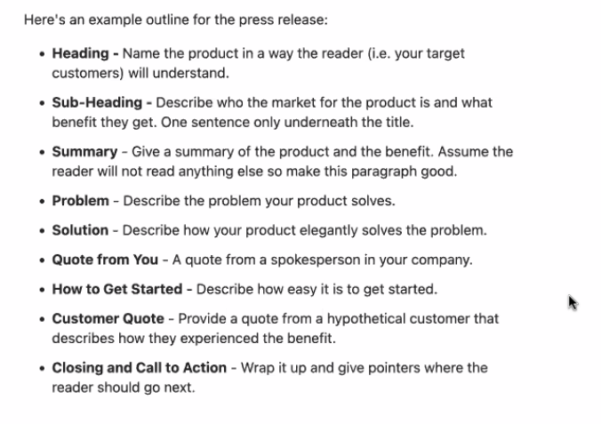
  - If the press release is hard to write then your idea is not yet crystal clear.
  - Write the releases in Oprah-speak. (Sokakataki insanın anlamasını sağlıcak dille, günlük hayyattaki kelimelerle)
  - Sonra press release bi guideline olarak kullanılabilir eğer releasete olmayan bir şey buildliyolarsa neden bunu yaptıklarını sorgulamalılıar. Doğru bir eklenti mi yapıyorlara bakıcaklar.

Business Plan (Result of the Design Thinking)
- The What? Why? How? Of your business.

- Belirsizlik daha çok iken yapıyosunü, test amacı ilçin kullanıyosun. Revize ediyorsun.
- Hipotez ve varsayımlar var vs.
- İş modelini olgunlaştırınca iş planınını yazıyosun.
- Bir organizasayonunun nasıl değer yaratıığı ,sunduğunu ve aktardığını anlatır.
- Marketingi en başta düşünüyosun. Zaten hayal ettiğin şey cepte hadi bakalım onu sat şimdi.
- Herkesi dinleyin, anlayın, kendi bildiğinizi yapın. (Herkesin istediğini koyarsanız çorbaya döner)
- Kilit Ortaklar
  - Kilit ortaklarınız, tedarikçileriniz kim? Riski ve belirsizliği azalt optimizasyon ve ölçek ekonomisi yarat.
- Kilit etkinlikler
  - Ana işiniz ne?
  - Üretim, sorun çözme, tedarik zinciri, platform. (Neleri insource neleri outsource yapıcaz?)
- Değer önerileri (Size özel değer, rekabet avantajı, neden size kullanmalıyım)
  - Marka, kullanım kolaylığı, düşük maliyet, teknoloji üstünlüğü
  - Network etkisi: Artan müşteri sayısının şirketin sağladığı faydaya bi eklentisi var mı? (Social networks mesela)
  - Marketplacelerde mesela netwwork etkisi çok önemli. Winner rtakes all.
  - Use your insight: Why is your model/innovation going to work as opposed to your predecessors? What is your advantage?
    - Founder’s advantage: You are the 1st person to use this solution on this problem.
    - Market advantage: The market is rapidly growing and there is an opportunity gap for another company.
    - Product advantage: Is your product an order of magnitude (10x, 100x) better than your competition?
    - Customer advantage: Is your customer base growing by word of mouth? Word of mouth is the cheapest and strongest way of growth. If your growth is solely based on the ads you run, then you can easily be challenged.
    - Monopoly advantage: As your company grows does it get stronger? Marketplaces and networks for example demonstrate this very well. More people use your network, not only do you grow but also other network’s get weaker. Similarly for marketplaces, more people would want to shop at somewhere they know they can find everything and more shops will want to sell there as they know they can reach more people.
- Müşteri ilişkileri
  - Müşteri nasıl elde ediyoruz, büyütüyoruz, elimizdezde tutuyoruz, sadakat programları?, kişiye özel hizmet? Vs.
- Müşteri kesitleri (Müşteri kitlesi
  - Yeni bir ürün grubu mu sundum
  - Mevcut bi pazarda rekabete mi girdim
  - Bir pazarı yeniden mi paylara bölüyorum.
  - Müşteriler ne alıyolar, neden alıyolar.
- Kilit kaynaklar
  - Bu iş modelinin hatata geçmesi için en çok ne lazım, insan mı, düşünsel (patent, yaratıcılık (Disney)), fiziksel (makine veya bina), finansal (para) mı?
- Kanallar
  - Müşterilerimize nasıl ulaşıyoruz?
  - Satış sonrası mutlu oluyo mu yeniden kendini sorguladıında.
- Maliyet yapısı, (Değiken sabit)
  - En pahalı kaynaklar neler, ölçek ekonomisi kullanabiliyor muyuz?
  - Gelir modeli (Abonelik, satış, reklam, raise and?)
  - 1/10th of market cost is gold. (When you are competing for the best price)
- 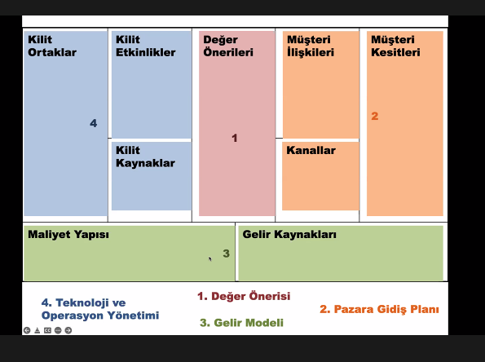
- My business plan template:
  - Name:
  - Sector:
  - Problem:
  - Solution:
  - Products:
  - Manufacture Method:
  - Target Market:
  - Competitive Edge:
  - Marketing Strategy:
  - Revenue Model:
  - Scaling Model:
  - Advantages:
  - Disadvantages:
  - R&D Forecast:
  - Time to Market:
  - Partners:
  - Funding:
  - Needed Workforce
- Lean business plan template
  - Problem: Describe your business in one sentence. What do you do and who do you do it for? For example, a bikeshop’s identity might be: “We offer high-quality biking gear for families and regular people, not just gearheads.”
  - Your identity is what sets you apart from the competition. It’s how you define who you are as a business.
  - Our solution: Describe the problems that your potential customers have. Why do they need your products or services?
  - Target Market: Who are your customers? Describe your ideal customer here and, if you know, how many of them there are.
  - Competition: What other products and services do your potential customers use today to solve their problems? How are you better than the competition?
  - Sales channels: Describe how you will sell to your customers. Will you sell directly to them at a storefront or with a website? Will you use a sales team or distributors? Describe your sales process here.
  - Marketing activites: What are the primary ways you will reach your customers? If you will be advertising or using PR, describe those activities here.
  - Revenue: What are your primary revenue streams? Don’t worry about listing specific revenue goals when you are early in the process. Instead, describe how you will make money and what products or services will generate that revenue.
  - Expenses: List your major expenses here. There’s no need to go into a lot of detail in the early stages. Just list the areas that you expect to spend the most money on.
  - Milestones: List your primary goals and objectives that you hope to achieve over the next few months. What do you need to get done to take your business from idea to reality?
  - Team and key roles: If you have business partners or need to hire key people to help you launch the business, list those people and positions here.
  - Partners and resources: Some businesses need key partners in order to launch. Other businesses may have intellectual property or other resources that will help them get up and running. List those partners and resources here.

What is a startup? M FUI
- After finalizing your business plan this means that you now have a problem, a solution and a strategy. And if you did the previous steps correctly each of these are sound as well. The next step is to build it, this will take time, effort and money. Time and effort have to be spent regardless but if you can’t afford to finance yourself this is the first step you may be considering external funding. (i.e. seed (Since you are not operational yet) funding)
- After the entrepreneur gathers their team and after what the problem and the initial solution is going to be is decided, now is the time to build that solution. Building, testing and scaling your solution takes time. In this step of the process you will be building a startup, receive funding to keep you and your people working and start selling your product.
- Startup: Tekrarlanabilir ve ölçeklenebilir bir iş modeli arayışında olan organizasyon.
- Startup-Hızlı büyüme için kurulmuş bir şirkettir. Tek ölçü hızlı büyüme. Hızlı büyümenin kaldıraçları: Sermaye, iş gücü, mekanizasyon, kod (bir kere yaz, yaygınlaştır, kullanmak için para öderler sana. Marjinal karı olağanüstü yüksek.), medya(medya yaratıp, gönderme, viral vs. ile yayılabiliyosun, PR yerine modern medya ile pazarlama fırsatı güçlendi.)
- Sürdürülebilirlik karakteristikleri star-upın: Yeni bir Pazar yaratmaya, var olan pazara dönüştürücü ürün sunmaya, çeşitli algıları kırman lazım ve zor bir şey bu. İşin doğası gereği bir hafta çok iyi bir hafta çok kötü olabilirsin.

Going Legit: Establishing Your Startup Legally
- Do we need it before funding idk
- Business banking, Paypal etc. accounts.

Funding- When and where? The Funding Ecosystem
- If you're starting a small business with a loan you're a moron. There are so many uncertainities but the one constant will be the loan.
- Bazı girişimler zaten müşterisi varsa 100M$ değerinde. Müşter bulmadan yatırım alıyolar. You can leverage that if you want investment.
- Bankalar iş başarısız olsa da ödeme ister, MELEK YATIRIMCI: Başarılı olursan hisse ver, başarısız olursa no payback, sağlık olsun. Resmen melek abi, vay mk.
- Sonradan pişman olucağın %45leri filan verme erkenden. Max %25 çııksın elinden funding için.
- Controlling sherden feragat etmen söz konusu bile değil.
- Start-up hızlı büyüme amaçlar yatırım araçlarına bakar.
- Start-ups are lead by entrepreneurs funded by venture capital firms or angel investors. A start-up can get funding at any stage.
  - Pre-Seed Funding
  - Seed Funding
  - Series A Funding
  - Series B, C, D… Fundings

The Pitch Deck
- Value proposition
- What’s the problem
- Market status quo
- Our solution
  - Methodology
  - Qualifications
  - Benchmark
- Business model
  - Pricing
  - Cost
  - Revenue model
  - Payment & legal model
- Roadmap
- Marketing and sales
- Team
- Finances
- Competitors
- Planned use of funds
- Tips
  - Use 10-20-30 model:
  - Use 10 slides. No more. Okay maybe two or three more. But that’s it. Slide decks are meant to get another meeting, not close a deal right then and there. You don’t need 20+ slides.
  - Be able to do it in 20 min. So practice and refine it until you can. There’s also almost always an unexpected problem with the projector or something, so that helps with staying on time.
  - Use 30 point font. It makes your content stand out and is easy to read across the room. If you can’t read it across the room, then it’s too small.
  - Make the background black and the text white. It stands out, “looks boss,” and is authoritative.
  - Integrate pictures and humor to help you display a point

How to scale?

R&D

General Remarks About Product Development
- “New” Products in the World
  - 10% New to the world
  - 20% New to the firm
  - 26% Addition to existing product line
  - 26% Improvements
  - 7% Repositioning (Such as selling baking powder for its cleaning power))
  - 11% Cost reduced form of the same competing products
- During the design stage very little actual cost (5%) is committed to the project but a good or a bad design drastically changes how much cost will be committed in the long run. (75%) Therefore a good design is very important and should be thought upon carefully.
- People you need to produce your product
  - Research: Using books, articles and any other relevant material they find the necessary information for the development team to use. (Can be the same people in the development team)
  - Development: Produces a technically sound product using research and past experience.
  - Design: Makes sure that the technically sound product is suitable for human use. Thinks of hypothetical cases the user might approach the product, makes everything as intuitive to understand and use.
  - Manufacturing: Creates the physical form of the product. (In case of physical products) (Can be outsourced to workshops and factories)
  - Operations: Coordinates the supply of the manufactured products and the distribution of the sold ones. Coordinates the external team. (Outsourced operations)
  - Marketing: Creates advertisements to make more people want to buy the product. (Can be outsourced to an ad agency)
  - Sales: Actually conducts the transaction where the product is given and the money is taken. (Can be outsourced to retailers or marketplaces like Amazon)
  - Management: Coordinates the internal team.
- Product Life Cycle:
- 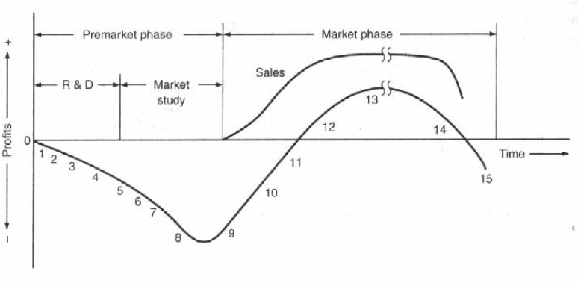
- Steps 1-3 are already finished by using the design thinking method, resulting in a human-based problem and it’s solution.
- Premarket phase
  - 1. Idea generation
    - You can utilize the competitive edge of your core idea:
      - Tech lead
      - Cost lead
      - Customer-based lead
  - 2. Idea evaluation
    - Do a product screening of the possible competition
    - Decide on what your product should achieve and how it will surpass the competition. (If suitable come up with technical target specs that puts your product over others)
    - 1. Concept Design: The specs, what should be researched, initial configuration.
  - 3. Feasibility analysis
  - 4. Technical R&D
    - Hire the necessary help
    - Put in the time
    - Come up with your first design called the minimum viable product. (MVP)
    - The MVP should have all the key components of your solution. Now you can test your product at its infancy and get pre-market feedback to further improve it. (Alpha, beta, gamma… tests)
    - 2. Initial Design: Configuration changes, technical analysis and revisions
  - 5. Product (market) R&D
    - Just as in the design thinking stage using focus groups, observation, interviews etc. test your now functioning product with people.
  - 6. Preliminary production
    - 3. Manufacturing design: The nuts and bolts phase. Decide on how the parts will be manufactured and assembled.
    - Start producing the first samples of your products.
  - 7. Market testing
    - Extensively user test your products.
  - 8. Commercial production
    - Get ready for launch, mass produce your products.
- Market Phase
  - 9.Product introduction
    - Launch of the product
  - 10.Market development
    - Scale your operations, get more and more customers.
  - 11.Rapid growth
  - 12.Competitive market
  - 13.Maturity
  - 14.Decline
  - 15. Abandonment

Sales
- Stripe
- No taxing etc.
- Vergi ödemeden amerikada şirket kurmak non us citizenlar için, usteki şirketinde stripe üzerinden alıyomuş parayı.

Revenue Models
- Sale, subscription, per use.

Where to Sell Products

Marketing
- It's better to to have 100 people who love you than to have 1 million who kinda like you. These make your business grow. (Talk with small groups of people, take feedback, resolve, make better)
- Growtech, tapfliate.com, tapfliate alternatives kullanın veya organic growth yapın SEO vs. Tapfliate satıştan pay veriyosun o reklamı yapıyor, sen gelir elde ettikçe o da gelir elde ediyor.

How to sell?
- Persuade people to buy your product: Biology: Cross section of human brain. Outer brain what rational +language, middle brain how feeling decision no language when w ego from outside in they understand all the info but it just doesnt feel right, it doesnt drive decisions. When you communicate from the inside out it feels right, that is what drives decision. Orville and Wilbur were driven by changing the World. Langley was driven by fame and Money. Day the brothers flew Langley quit. You cant attract those who believe what you believe
- Customers: 2.5 innovator, 13.5 early adapters, 24 early majority, 34 late majority, 16 compulsory adapters. Early majority, daha önce kullananlar beğnmiyorsa productu almıyor. %15’lik maarket penetrationu geçince tipping point işte. O yüzden early adapterların anlaması lazım ve bu early adapterlar da gut feelingle, i just get it olayıyla adaptliyor. O yüzden bunlara hitap etmek için Whhy dan girmen gerekiyor. (Diffusion of Innovation)
- Japanese never use quality in their marketing. People don't form opinions on quality by marketing, they form their opinions on their experience with the products.
- About selling a pen: You don't desribe and sell a pen. Only rational thing you can do is. Star asking them questions. The key to selling is finding our What your client needs, values.
- How to sell anything to anyone
  - Dont sell logic, sell emotions and desires
  - Dont let the prospect lead the conversation
  - Push emotional triggers find where it hurts.
  - Use poweful words, build certainity in the customers mind.
  - SHOW them how you are going to make their lives easier.

3 Lines Theory (What is the aim of marketing?)
- 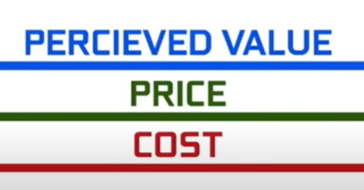
- Lines can never cross!
- People won’t buy something if it’s perceived value is lower than its price.
- You can’t sell something if it’s cost is more than its price.
- Margin= Price-Cost You want this to be high.
- Keep cost low
- Price high = Perceived Value high
- Market Value=Percieved value-Price
- If something is cheap for its value there will be more people buying it
- Keeping perceived value high
- Exclusivity/Scarcity
- Keeping cost low: Technical
- Making a lot of profit
  - High market share, then you can use economies of scale to lower your cost. (Ford)
  - Low market share, raise prices to meet perceived value. (Ferrari)
  - High market share, high prices (Apple-Philosophical & also sells a lot, has a following)

Branding
- Tarihten marka koklulugu ve marka adlarindan cok kazaniyor bati dunyasi

Brand Naming
- Eponymus: İnsan adından
- Descriptive: Home Depot
- Acronymic: KFC
- Suggestive: Uber (Super)
- Composite: Facebook
- Inventedd: Pinterest
- Associative: Amazon (With the rainforest)
- Non-english: Lego
- Abstract: Rolex (Phonetically strong)
- Idea+Emotion: Google (100.00000…)
  - Check for meanings in other languages

Creating a Brand Following
- Aim of all companies today, look at 7/11 and their car culture

Advertising
- Look at which products needs ads and which dont
- How does montblanc announce a new pen, the media announces it for them. Luxury usually doesnt advertise, people come to them.

Competing
- Rakip platformu filan yakalayınca onları kelime kelime dinliyor. Bugün canlıda 350k kullanıcı oldu, iki ay sonra 300k oldu demiş canlıda. Demek ki yalan söylemiş diye anlayabiliyorsun. Aynı şekilde de canlıda/kayıtta konuşmak tehlikeli.

Exit
- how to become a billionaire, ilk businessını sector multplierla leveragelayabilirsin eğer daha büyütmek istediğin bir şey değilse, o multiplierla satıp istediğin işi kurup milyarı görebilirsin
- Big companies will invest in or acquire early bird startups of the current trends regardless of how they will perform in the future. Minimizing the risk of being left behind is much more important than holding onto money for these big firms, because being left behind is the only way these huge companies collapse. (If microsoft dominates web search with openAI than it can kill Google as simple as that) And since big firms move very slowly they invest in much more dynamic startups to fund and be a part of breakthrough technologies. You can use this principle to make an exit with your company.
- Big companies have money, a lot of money. Their constrains lie in time not finances therefore if you are developing a technology they are interested in they will gladly buy it off your hands

Where to sell your business?
- Microacquire.com – Micro girişim exiti yaptırıyor.

So You are Rich, What Now? Invest.
- Inflation is soaring cant put it in a bank. Real estate difficult. Currency markets trash. Stock markts going to zero now. MUST INVEST IN STARTUPS!!!
- Use high risk tools smartly to build your wealth, reinvest into low risk dividend stocks to use your wealth.
- Put your money to work. You can't get rich by storing your money. Invest in appreciating assets.
- Rich people buy what makes them more money, poor people lose money when buying something.
- Never be afraid to take calculated risks. Those who play it safe never make it big. (Poker oynamak lazım)
- Buy 1$ for 0.66$
- Google
  - They generate revenue through their products.
  - Invest in startups in related areas for tech breakthrough
  - Invest in long term areas that needs investing, it was AI until now
  - Invest in unrelated emerging technologies. Biotech etc.
- Types of investments.
  - Venture Capital: Venture Capital: is to invest in a startup that they think are going to be +10x in 10 years 15x 20x even 100x.
  - Stock Market
  - Cryptocurrencies
  - Housing
  - Commodities (Gold, petrol, water)
  - Restaurant
  - Tech Company
  - Startup
- When central banks print a lot of money, buy stocks, gold and commodities.
- Hem gelirini harcırak olarak cebine koyup hem de yatırım kapitalini düşürmemenin yolu ne. Dividends and other investments that do regular payouts.
- A VC is competing against a money that would become 10x in 10 years. So the job of the VC
- Compounding powers the world.
- Make your investments on if that is going to change people’s lives
- Principles of World Powers
  - Rise
    - Win power by defeating the opposition (Old world leader etc.)
    - Consolidate power within country
    - Establish systems and institiutions
    - Choose successors (You cant rise a country in one life time)
  - Peace, Prosperity
    - Strong education, civility, moral – Common Purpose
    - New technologies
    - More productive
    - More competitive in world market
    - More economic output
    - More share in the world trade
    - To protect this prosperity increase military strength
    - Then you use this new found prosperity to feed back into the education, trade and conquest sectors. You do so by using the capitalist approach, by providing entrepreneurs with money using lending, bonds and stocks. This is a strong financial capital system.
    - When you hold this big a share in the world trade your currency becomes widely accepted and it starts being used as a reserve currency. (A currency you can simply print out wwhenever necessary)
  - However since you can and do print more currency your power starts to become a bubble.
    - As you print more money and your salaries go up. A worker in the US becomes less competitive against foreign workers who will do the same job for cheaper.
    - Similarly your tech starts to be copied and start to be produced for cheaper that makes you lesss competitive. The british hired dutch ship designers and produced the ships in the UK resulting in high quality ships for a more competitive price. Same for China today.
    - GEREKİNCE PARA BASMAYA DAYANMAYAN STABİL, SELF SUFFİCİENT, BUSİNESS LİKE GOVERNED BİR ECONOMİC SYSTEM LAZIM. SWİSS?
    - Richer countries get deeper into debt by borrowing from countries that save more. (Borrows back dollars since it s the reserve currency)
    - As the empire runs out of its lenders those who have an IOU starts looking to get out instead of getting in by bonds.
    - This couples with the internal wealth inequality gap that widened during the peak of the empire results in internal and external conflicts.
    - The government since it cant pay its IOUs starts to print a lot more money not to default. This results in inflation.
    - To combat inflation governments try increasing the tax and since mostly the rich are now holding the country’s assets these rich people run aay from the country with their money to safer harbors further decreasing the countries income.
    - The rich left behind may get lynched, revolution or a civil war breaks out.
    - Seeing this external powers seek to collapse that empire by attacking etc. Winning this war they get more money and start their own rise.
    - Principle: EARN MORE THAN YOU SPEND & TREAT EACH OTHER WELL

Doing it backwards: Rise of the Digital Creator
- Creator: Content
- Maker: Product
- Indie Hacker: Revenue generate etme amaçlı herhangi bir şey. Dolayısıyla düz bu ters değil. Entre denebilir sadece scalei daha küçük, funding almaz vs. Poor man’s entrepreneur.
- And want to have communities.

BFFs with the Government: The Contractor Way
- İhale alinca 70% veriyor parayi
- Alt sistem daha cok para kazandirir ana sistemden
- Mesela kompozitle uretmeyi biliyorsun
- Bi sey uretirsen para var ama uretebilmek mesele
- Ustteki !!!
- Ureten de satan da sen olcan ki kar et
- Alt sistemi sen uretcen veya ana sisteme kadar da buyutcen
- Ama alt sistemi almican mumkun oldukca

